|  |
| --- |
|  |

TITEL (stijl titel)

ondertitel (stijl sub paragraaf)  
  
Dienst/afdeling  
Datum

# Building with living nature

conceptual elaboration

### Drs Carla Pesch, Delta Academy

### Bregje van Weesenbeeck, Ph.D, Deltares

### Myra van der Meulen, M.Sc., Deltares

### Delta Academy, research group building with Nature Datum vlissingen

### Versie

# ****Inhoudsopgave (Stijl**** Hoofdstuk****)****

Voorblad (Genereren: Veld bijwerken) 2

Titelblad 2

Inhoudsopgave 3

Hoofdstuk Error! Bookmark not defined.

Paragraaf **Error! Bookmark not defined.**

Sub paragraaf **Error! Bookmark not defined.**

# Introduction

Climate change and sea level rise are creating big challenges to coastal zone management.

In the Netherlands, the Delta Commission defined strategies to meet these challenges. One of main points of departure in the approach chosen, is that the Netherlands is living *with* water in a sustainable way, where the basis for sustainable water management is defined as “moving along with natural processes where possible, resist where necessary, and using opportunities for prosperity and wellbeing” (Nationaal Waterplan, 2008). The background for this, is the increasing awareness of the limitations of the so-called “hard” coastal defenses with regard to flexibility and adaptability.

The concept “Building with Nature” follows the approach of moving along with nature, by actually also making *use* of natural processes. (Waterman 2008). Moreover, the Building with Nature strategy offers solutions that combine cost-effective and sustainable coastal safety with other functions, such as nature and recreation. Building with *Living* Nature is a special application of the Building with Nature approach, in which use is made of living nature, ecosystems, to contribute to flood control.

The implementation of Building with Living Nature concepts in coastal zone management is hampered by a lack of understanding of the logics of the approach, by lack of practical experiences using the concept and by the lack of an objectively validated framework for safety assessments. Due to this situation there is a lack of confidence in the usability of the concepts. The RAAKPro project “Bouwen met Levende Natuur” (Builiding with Living Nature) contributes to overcoming these obstacles. The overall aim of the project is to analyse BwLN concepts, in order to create a toolbox with area-specific possible solutions and concepts, as well as a framework for safety assessments for professionals. The underlying report is part of workpackage 1 of this project. This workpackage specifically aims at creating a conceptual framework for the BwLN approach (in relation to coastal protection), inventorizing BwLN solutions used, and identifying gaps and obstacles for implementation. The inventory of BwLN solutions used is presented in a database that also includes primary, secondary and tertiary ecosystems services supplied by the BwLN solution in question. The underlying document focuses on the conceptual framework, and is produced as a cooperation between the Building with Nature Research Group of the Delta Academy – Applied Research Centre (HZ University of Applied Sciences,Vlissingen) and Deltares. This is the second report in a series of three reports, of which the first one focusses on the historical perspectives on the Building with Living Nature concepts. The third document will become a chapter in a book on Ecosystems and Disaster Risk Reduction, published by the UNEP organization PEDDR (Partnership for Environment and Risk Reduction).

### the natural situation as point of departure

The Building with Living Nature approach is based on flood protection properties of natural habitats. The “living shorelines” approach (Slear 2012), an approach that is closely related to the Building with Living Nature approach, uses natural habitats or habitat elements to stabilize and protect eroding shorelines. Here, the elements of the natural coastline, can be seen as “building blocks”. Each building block contributes to flood protection (fig.1).

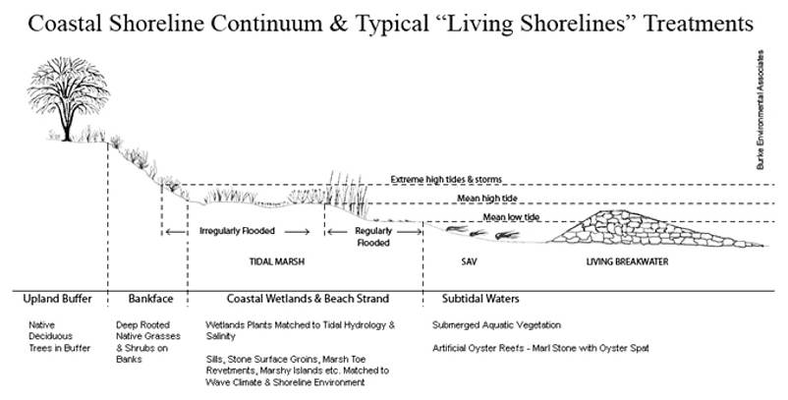

*Fig.1 A living shoreline with its “building blocks” Source:* [*www.habitat.noaa.gov*](http://www.habitat.noaa.gov)

Oyster reefs, for example, will attenuate waves (Borsje et al. 2011). This will not only decrease the wave energy in the direction of the coastline, but also lessen the erosion of the intertidal areas between the reefs and the coastline sediment.

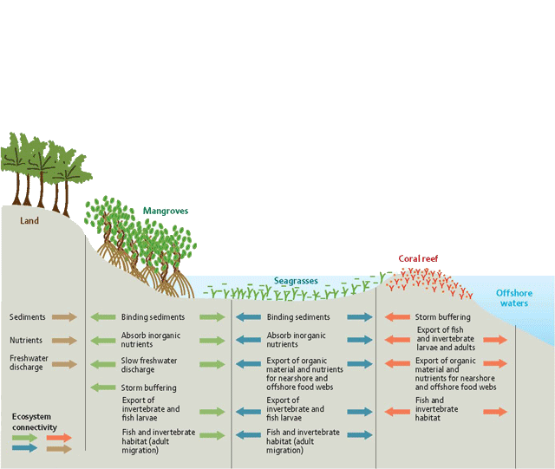

*Fig.2. A living shoreline from the tropics, showing both building blocks and ecosystem services supplied. . Source: Adapted from Americas.iweb.bsu.edu*

Coastal areas, especially delta’s, however, are often not only hotspots for nature. They are also economic hotspots. Although it is obvious that man can not survive without the services supplied by nature, such as food production, gas regulation, etc, it is not feasible to reserve all the space available for nature. At the same time, coastal protection needs to be guaranteed as much as possible.

Examples of systems where one or more elements of the continuum are substituted by artificial structures can be found in e.g. the Eastern Scheldt. At Viane and de Val, a shoreline continuum of artificial oyster reef – intertidal area – dike can be found. At Viane and St. Annaland, the series intertidal area - salt marsh – dike, as shown in the schedule presented in fig. 3, is found. And in an experimental design near the Oesterdam, also in the Eastern Scheldt, you will find artificial oyster reef – intertidal area that has been suppleted with a sand nourishment – dike.

In all these cases, however, structures are used that mimic the natural situation .

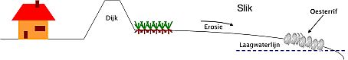

*Fig. 3 Shoreline continuum comprising a dike and an artificial oyster reef*

Source: <http://www.innovatielocaties.nl/building_with_nature/oesterrif>

In this approach, care should be taken to select building blocks that belong in the biogeographical zone. Environmental conditions are limiting for the options for ecosystem selection. In temperate zones for instance, it will not be feasible to include a mangrove ecosystem for flood defense. This issue will be addressed in paper, van Wesenbeeck et al, Ecosystems for flood risk mitigation: Physical restrictions and engineering challenges, that will be published in the PEDDR (UNEP) book on on Ecosystems and Disaster Risk Reduction.

The concept of building blocks can even be applied *within* a building block. E.g. on a dike, structures that contribute to better chances for nature values can be included, such as small pools (fig. 4). Or the choice of revetment materials can be adjusted, to enhance nature values. In that way, structures that were built for coastal protection only, can still be given additional values, additional ecosystem services. In pools created at the dike of Ouwerkerk, intended for enhancing opportunities for nature, it was observed that life in the pools attracted tourists, especially children, from the neighbouring camping site. In that way, not only nature values were enhanced , but also recreational values.

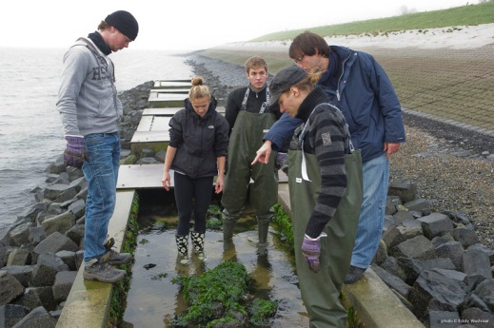

*Fig. 4 A so-called “rich revetment” at Ouwerkerk. In this case, a series of pools were included in the revetment*

The aim of this paper is to provide a conceptual elaboration of the Building with Living approach. The main focus will be on the relation between the BwLN approach for flood protection and the concept of ecosystem services.

This report is written for professionals in the field of flood protection, thereby creating grips for engineering, in order to enable the incorporation of Building with Living Nature solutions in their designs.

# building with living nature solutions: making use of services supplied by ecosystems

In this chapter, the relationship between the Building with Living Nature approach and the concept of “ecosystem services” is elaborated. Moreover, the idea of the provision of primary ecosystem services and secondary, tertiary etc services is explained. This is the basis for the potential of the BwLN approach to attain multiple goals.

*Building with Nature (BwN)* is an approach that focuses on solutions that make use of natural processes and structures. This may include both biotic (living) and abiotic (non-living) parts of the system. An example of the use made of abiotic processes, is the use made of wind and currents to disperse sand and reinforce the coastal foundation. *Building with Living Nature (BwLN)* is using biotic structures and their processes, such as for example mangroves, or oyster reefs, for dampening waves and/or increasing sedimentation, thereby increasing coastal protection.

### introduction to ecosystem services

The introduction of the concept “ecosystem services” (ESS) goes back to the 1960s and 1970s. In the 1990s, there has been an increase in publications (De Groot et al. 2002 and references therein), but the big breakthrough was in the Millennium Ecosystem Assessment (MEA) (synthesis published in 2005). In this assessment it was found that worldwide around 60% of the ecosystem services are degraded or used unsustainably. As a follow-up, a study on “The Economics of Ecosystems and Biodiversity” (TEEB) started in 2007, and was finalized in 2010. The TEEB study (2010) aims at assessing the economic impact of the global loss of biodiversity. Where the Millenium Assessment takes the ecosystems and the loss of biodiversity as the focal point, TEEB focuses on the global economic benefits of biodiversity, highlighting the growing costs of biodiversity loss and ecosystem degradation. The TEEB project combined expertise from the fields of science, economics and policy.

#### Categories of ecosystem services

The categorization of ESS, as used by the MEA (Provisioning Services, Regulating Services, Cultural Services, Supporting Services) differs slightly from the one used by TEEB (Provisioning Services, Regulating Services, Habitat Services and Cultural Services & Amenities). Table 1 presents a comparison between the categorizations used in the Millenium Assessment, by the TEEB project, and by de Groot et al. (2002). For the categorization of services, this report follows the TEEB system, since this is the most recent categorization proposed by a large platform of specialists in ecosystem services.

*Table 1 Comparison of terminology and categorization in ecosystems services. Supporting services (Millenium Assessment) include processes such as soil formation, photosynthesis, nutrient cycling, provision of habitat*

|  |  |  |
| --- | --- | --- |
| De Groot et al. 2002 | Millenium Assessment 2005 | TEEB 2010 |
| Production functions | Provisioning Services | Provisioning Services |
| Regulating functions | Regulating Services | Regulating Services |
|  | Supporting Services |  |
| Habitat Functions |  | Habitat Services |
| Information Functions | Cultural Services | Cultural Services |

|  |
| --- |
| **BOX1**  **ECOSYSTEM FUNCTIONS AND ECOSYSTEM SERVICES**  ecosysteem - ss.jpg  *Fig. 5 The relation between ecosystem services, ecosystem function, and the ecosystem processes & structure underlying the ecosystem services. Ecosystem function represents the link between ecosystem services and the underlying ecosystem structure & processes. Here, ecosystem function is defined from an anthropocentric point of view. Based on de Groot et al. (2002).*  De Groot et al. (2002) distinguishes functions on the one hand, and goods & services on the other hand. In this terminology, goods & services are the benefits for humans. Storm protection (e.g. by coral reefs) or flood protection (e.g. by wetlands) are services. Ecosystem functions, such as sediment capture or wave attenuation, are the link between ecosystem services, and are underpinned by ecosystem processes & structure. In this framework, ecosystem processes & structure are intrinsic attributes of the ecosystem, whereas the ecosystem function is defined from an anthropocentric point of view. For instance, gas regulation is an ecosystem function that is based on biogeochemical cycles of ecosystems (e.g. CO2/O2 balance, ozone layer). The services obtained from this function is maintenance of a good air quality, or UV-B protection by O­3, or effect on climate. (de Groot et al. 2002) In other words: ecosystem services are part of the socio-economic system and not of the ecosystem, a function becomes a service as soon as humans make use of it, either consciously or unconsciously. Ecosystem functions are the link between the ecosystem services and the ecosystem itself. Costanza et al. (1997) use a similar terminology. Barbier et al. (2011), however, consider ecosystem processes and functions as part of the ecosystem and see ecosystem goods and services as the intermediate between the ecosystem and the economic system, where values can be given to goods and services. Both the MEA and the TEEB categorization, however, only use the word ‘services’ referring to both ‘services’ and ‘functions’ as distinguished by de Groot. Figure 1 is based on a part of the schedule by de Groot et al. (2002), and presents the relation between ecosystem services, ecosystem function and ecosystem structure & processes. This report is following the TEEB categorization of ecosystem services, but it will follow the use of terminology as to ecosystem *function* and ecosystem *services* used by de Groot et al (2002), as this is more precise from a biological point of view. |

### Inventories of ecosystem services for coastal ecosystems

A number of efforts have been made to produce inventories of ecosystem services related to specific ecosystems. (MEA 2006, Barbier et al. 2011)

*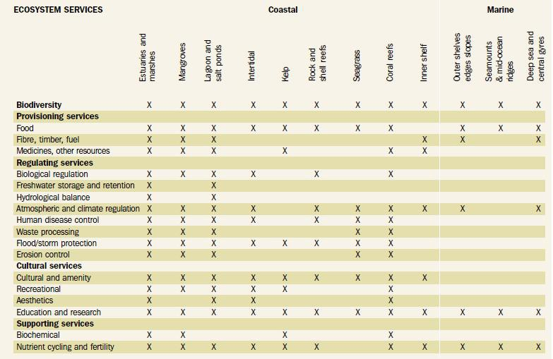Table 2 Examples of ecosystem services provided by different marine and coastal habitats. From: Marine and Coastal Ecosystems and human well-being: a synthesis report based on the findings of the Millenium Ecosystem Assessment, UNEP 2006*

A general overview of services, including their valuation, was published in 1997 (Costanza et al 1997). Alongside the MEA (2005), there was an inventory published by UNEP (2006) of services provided by marine and coastal habitats. Table 2 provides a general overview. A more detailed overview, including a valuation, of estuarine and coastal services per habitat was published recently by Barbier et al. (2011).A comparison between goods and services provided by 7 specific marine environments was made by Beaumont et al.. (2007). Some of the above studies are not very specific in the indication of ecosystem services and /or underlying ecosystem processes & structure (Costanza et al. 1997, UNEP 2006, Beaumont et al. 2007). Barbier et al. (2011) provide more details, especially concerning processes that form the basis for the described ecosystem services.

Building with Living Nature solutions related to coastal protections, will usually primarily aim at improving or reinforcing flood protection effects such as wave attenuation and dissipation, and erosion control. Therefore, the design of Building with Living Nature applications for flood protection will need e thorough understanding of these underlying processes, as will be explained later in this chapter.

### building with nature and ecosystem services

The Building with Living Nature approach uses ecosystem services, hence ecosystems, for finding solutions. In order to be able to design and/or maintain healthy and resilient ecosystems, it is of importance to understand the processes and structures that are the basis for these ecosystems.

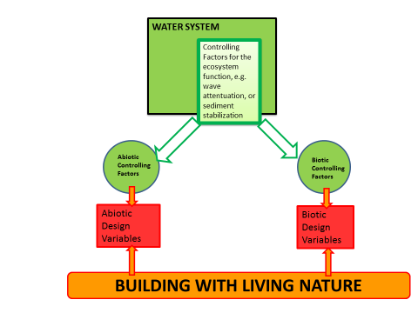

*Fig. 6. The relationship between the BwLN approach and the key ecosystem structure & processes that are underlying ecosystem services. Design variables are controlling factors that can be used to manipulate the system, hence to design, maintain or reinforce the BwLN solution*

Ecosystem services related to coastal protection are provided by shellfish reefs, salt marshes, mangroves, coral reefs etc. Once the most suitable ecosystem is selected, i.e. an ecosystem belonging to the biogeographic zone and the dynamics of coast in question, it will be necessary to understand how such an ecosystem can be designed, reinforced or maintained.  
For the design with Building with Living Nature solutions, the abiotic and biotic factors controlling or steering the desired ecosystem function(s) that is/are used for coastal protection are to be identified. E.g. wave attenuation by shellfish reefs, will, amongst other things, be dependent on the dimension and orientation of the reefs.Not all controlling factors can be influenced by humans. Those that can actually be influenced are key in designing, reinforcing and/or maintaining BwLN solutions.

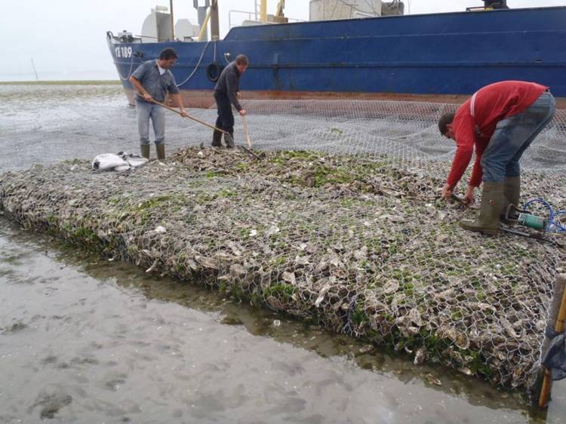

*Fig. 7 The creation of an artificial oyster reef in the Easter Scheldt (source: Ecoshape website). Oyster reefs can stabilize sediment and are therefore able to prevent erosion of intertidal areas. Furthermore, oyster reefs will attenuate waves. Natural oyster spat will attach to the artificial reefs, and the artificial oyster reef will develop naturally. Oyster reefs are expected to keep pace with sea level rise.*

For example, in the case of an artificial oyster reef (fig. 7), abiotic design factors include the substrate or the gabion materials used. Biotic design factors include the reefs’ dimensions and the presence of grazers, e.g. *Littorina sp.* These small snails forage on algae, thereby preventing overgrowth of the oysters. Figure 8 presents a schedule of the relation between the Building with Living Nature approach and the ecosystem structure and processes that underlie the ecosystem services.

Up till now, the main focus in Building with (Living) Nature designs has been on the abiotic factors. However, if the BwLN solution selected is to create a *living* structure that can adapt to changing environmental conditions such as sea level rise, biotic factors are equally important. In the first place, habitat requirements of the ecosystem in question should be met. In this respect, much can be learned from restoration ecology, where approaches used vary from creating improved conditions for the ecosystem in question to even the introduction of species. In order to make optimum use of the desired ecosystem service, however, the controlling factors for the ecosystem function on which the ecosystem service is based, should be given more attention.

**controlling factors and design variables**  
BwLN solutions are based on ecological knowledge, i.e. knowledge of the structure and processes of the ecosystem in question. A brief overview of controlling factors and design/engineering variables for flood protection services is presented in table 3. Please note that this table is only meant to explain the concept, and is not an exhaustive overview. Moreover, the table focuses on ecosystems that can be used for flood protection, and on the controlling factors that are most relevant for the ecosystem services related to flood protection.

Table 3 Ecosystems that can be used for flood protection(wave attenuation, wave dissipation, erosion control) and the main controlling components, primarily related to the flood protection ecosystem service. This table only shows an indication of the approach and is far from compete. The table is composed from literature (Koch et al. 2009, Barbier et al. 2011, Kaiser et al. 2005)

|  |  |  |  |  |
| --- | --- | --- | --- | --- |
| ECOSYSTEM SERVICE: FLOOD PROTECTION/EROSION CONTROL | | | | |
| Ecosystem and *region/climatic zone of occurence* | Key Controlling factors | | Design/engineering variables | |
|  | Controlling abiotic factors | Controlling biotic factors | Abiotic | Biotic |
| Coral reefs (nearshore)  *Indo-Pacific region; Caribbean, Red Sea* | * Submergence time * Water depth; Light availability * Turbidity * Nutrient availability * Pollution * Substrate * Water temperature * Silt influx * Wave height and length’ * Distance to shore | * Reef-building species * Reef dimensions * Zooxanthellae * Grazers – Algaebalance * Coral surfaceroughness * Proximity of sea grass and mangroves (nutrient supply and protection against silt) | * Substrate (artificial: biorock) * Reef dimensions and orientation; distance to shore * Water depth; submergence time * Nutrient availability * pollution * Protection against silt | * Reefbuilding species * Predator - Grazer -algae balance |
| Seagrass beds  *Both Tropical and Temperate zone* | * Turbidity * Nutrients * Submergence time; water depth above the canopy * Distance to shore * Light * Temperature * Salinity * Exposure to waves and wind * Latitude[1] * Subsidence; beach slope * Sediment properties * Coastal morphology * Tidal stage | * Seed availability * Seagrass species and density; reproductive stage * Seagrass bed size * Reproductive stage (seasonality) * Grazers – Algaebalance * Presence of *Arenicolamarina* | * Nutrient availability * Pollution * Salinity * Submergence time; water depth * Sediment type * Sea grass bed dimensions and orientation | * Seagrass species and density (aboveground biomass/water column ratio) * In reintroductions: spread of *Arenicola marina* in former seagrass beds * Grazer – Algaebalance |
| Mangroves  *Tropics and subtropics, low energy coasts* | * Flooding depth, duration and frequency * Salinity, fresh water availability * Shape of intertidal flat * Beach slope * Sediment availability * Fluvial sediment deposition * Coastal geomorphology * Distance to shore * Nutrients * Exposure to waves and wind * Latitude * Wave heigth and length * Tidal height | * Seed availability * Vegetation type and density (aboveground biomass; shape of vegetation) * Sesarmid crabs (keystone for nutrient recycling) * Other mangrove associated fauna | * Sediment availability * Flooding depth, duration, frequency * Sediment elevation, tidal creeks construction, zonation * Nutrient availability * Pollution | * (Re)planting - choice of species: aboveground biomass/water column ratio; * Shape: diversity; density * Propagule availability (no hydrologic blockages) * Sesarmidcrabs |
| Shellfish reefs  *Temperate zone* | * Submergence time * Distancetoshore * Sediment availability * Turbidity * Substrate * Exposure to waves and wind * Temperature * Salinity * Hydrodynamics | * Predator- Grazer – Algae balance; other uncontrolled epibionts * Predators on the shellfish * Shellfish reef species * Food availability | * Artificial: substrate, reef orientation, reef dimensions, water depth/submergence time * Sediment availability | * Shellfish reef species * Predator - Grazers – Algaebalance * Otheruncontrolledepibionts * Food availability |
| Salt marshes  *Temperate zone, high latitudes, low energy coasts* | * Water depth in and above canopy * Wave height and length * Tidal height * subsidence * Exposure to waves and wind * Local geomorphology * Sediment availability, fluvial deposition * Velocity * Distance to shore and load | * Marsh area and width * Species composition and density | * Sediment availability * Shelter - exposure balance | * Species composition and density * Marsh area * Marsh dimensions |
| Riparian wetlands  *Fresh water, temperate and tropical zones* | * Water depth in and above canopy * Distancefromshore * Nutrient load * Sediment nutrient content (esp. P) * Fluvial sediment deposition * Fluvial sediment load * Localgeomorphology; soiltexture * Hydrology | * Wetland area * Wetland species and density of vegetation * Seed availability | * Sediment availability * Soil texture grain size, bulk density?) * Floodingduration * Velocity * Erosion/sedimentation rates typical of wetland type * Nutrients/pollution in water and in sediment * Slope * Wetland area anddimension | * Species composition * Seed availability |
| Kelp  *Cold, nutrient-rich saline water; primarily mid to high latitudes* | * Availability of hard substrate * Light * Load of suspended matter * Nutrient availability | * Species composition * Sea otter-sea urchin balance (predator – grazer/herbivore balance) |  |  |
| Sandy beaches and Dunes  *Both temperate and tropical zones* | * Beach slope * Dune height * Sediment availability, sand supply * Wave length and height * Tidal height * Subsidence * Tidal stage * geomorphology | * Species composition * Vegetation density * Balance in Nematode groups | * Sediment availability (sand nourishments) | * Species composition and vegetation density * Nematode balance |

### multifunctionality of building with living nature solutions

BwLN solutions primarily aim at strengthening coastal protection. Additional services may also be strenghtened because the approach tunes design variables, that steer the key ecosystem processes and structures of the (coastal) ecosystem selected.

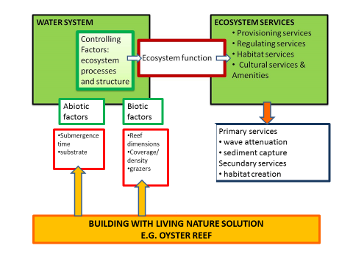

*Fig. 8 Building with Living Nature solutions use design variables (controlling variables that can be influenced by humans) to design, maintain and/or reinforce the ecosystem selected for its ecosystems services. The ecosystems usually supplies several ecosystem services. By addressing controlling factors, the BwLN solution has an effect on the the complete ecosystem, therefore also on other ecosystem services supplied. The orange arrows indicate the design, the red arrow indicates the output. Please note that the example presented is neither complete as to the analysis of abiotic and biotic steering factors, nor as to resulting the ecosystem services.*

Therefore, the whole ecosystem in question is strengthened, thereby also strengthening the other ecosystem services supplied.   
In this respect, the primary ecosystems services are the primary services the BwLN solution has been designed for (figure 8). The secondary ecosystem services are services that are also improved or created. Sometimes the additional services of a design are intentional, sometimes they are not. An example of an unintended effect is the increase in recreational value created by the Oesterdam sand nourishment. This BwN solution was designed to improve flood safety and natural value. Another example are the artificial oyster reef in the Eastern Scheldt. This BwLN solution primarily aims at sediment capture and sediment stabilization, thereby increasing or stabilizing wave attenuation and wave dissipation, both by the reef itself and by the intertidal flat between the reef and the coastline. These oyster reefs, however, could provide additional nursery habitats for fish. It could locally also lead to a complete shift in species composition by the increase in hard substrate, which in its turn could lead to an increase in nature values.

Concluding, BwLN solutions will oftentimes combine safety with other functions, simply because the ecosystems offer multiple ecosystem services.

.

### resilience

Additional services can be of importance when it comes to finding support for implementation of Building with Living Nature solutions. Out of the additional services, however, the habitat services will be most important in terms of ecosystem functioning. Obtaining stakeholder support apart from the nature organizations, however, will depend more on providing strengthening services from two other additional ecosystem services groups, i.e. provisioning services and cultural services & amenities (recreation, leisure, tourism is part of this latter group of services). An overview of BwN solutions with their primary and secondary and tertiary ecosystem services is presented in a report in which 34 cases are described (Hong, T. Building with Nature: from concepts to practice, 2011).

In this respect, however, attention should also be paid to the carrying capacity / resilience of the system: care should be taken not to induce over-use of those services.

#### keeping the balance between robust solutions and ecologically resilient solutions

A BwLN solution will favour species belonging to the desired system, creating a situation that could be compared with agriculture, or with aquaculture, where robust, stabile systems are desired, focused on a specific species. Safety traditionally asks for a robust and efficient solution, therefore for a high efficiency of the safety function. A traditional engineering solution is usually spatially uniform. This might, however, conflict with ecological resilience. The advantage of a BwLN solution, next to offering higher values for nature, lies in the larger adaptability to changing environmental factors, driven by climate change. Adaptability focusses more on keeping the safety function into existence.

The challenge here is to optimize the efficiency of the safety function, without losing the resilience of the BwLN solution.

If the focus is on *efficiency*  only, maintenance of the *existence*  of the function itself is not so easy. This can be illustrated by the example of the engineering approach for safety in river basins: as long as flood protection is controlled by a system of canalization, regulation and dikes only, efficiency (therefore engineering resilience) is high, but ecological resilience is low. In these times of climate change, where we have seen more and more extremes in the water peaks (therefore more disturbances, sometimes worsened by loss of the water retention capacity of the system that is caused by the canalization and regulation), this has proven to be an approach that is too limited: the flood protection function could not be maintained. The water management response chosen, the more modern “room for the river” approach, leans on a more natural situation of the river basin, and is more (ecologically) resilient. This approach combines ecological resilience with efficiency/engineering resilience. It allows meandering, a bigger water bed, and more natural shores including wetlands where possible, thereby allowing a larger volume of water in the system and increasing the water retention capacity. The natural functions and structure are restored as much as possible and a higher amount of ecological resilience has been created. At the same time, the approach does not solely rely on the natural flood protection structures, and also includes dikes, and strengthening of dikes where needed.

**BOX 2**

**Efficiency and robustness versus resilience** (Holling 1996)

**Traditional engineering solutions (sometimes also referred to as engineering resilience)** pertains to the *efficiency* of the function. In the example of a farmland, this would imply targeting at high yields of one specific species, at the expense of the natural variability of critical structuring variables. The production is then optimum and stabile, the efficiency is high. But the ecological resilience is low: the ecosystem is spatially uniform, functional diversity is low, creating a system that is sensible to disturbance. A system that is designed based on engineering efficiency as the only point of departure, lacks flexibility.

**Ecological resilience** pertains to the capacity of an ecosystem to maintain the *existence* of its function, structure and feedbacks loops. It is also defined as “the amount of perturbation a system can withstand before it moves into a different basin of attraction, or stability domain”. An ecologically resilient system maintains its functionality more easily, thereby maintaining the ecosystem services supplied. It also is more able to withstand disturbances. The strength of the BwN approach lies in the ecological resilience.

The BwLN approach is an engineering approach that uses the knowledge of ecology. It aims both at a combination of robustness/stability (therefore engineering resilience) and ecological resilience. The building blocks approach, where a dike can be combined with other safety structures in the water system, allows for such a combination. E.g. artificial oyster reefs will develop naturally, because oyster spat will attach to the hard substrate offered by the artificial reef. The system will therefore become self-maintaining.

The implementation of Building with *Living*  Nature solutions require a balance: for safety aspects, *efficiency* of functions such as wave attenuation and dissipation, and sediment stabilization, is important. Too much focus on this aspect, however, may lead to the loss of ecological resilience, therefore flexibility, and lose the ability to maintain the *existence* of the function. In some cases, a better option is to combine BwLN solutions with a straightforward engineering solution, such as a dike, in the zonation of a natural shoreline.

#### resilience and ecosystem regime shifts – what happens if pressures become too high

Where support for implementation of a BwLN solution can be found in other ecosystems services (e.g. production services such as fisheries) than the primary one (e.g. safety services), care should be taken not to induce over-use of that function (e.g. fishing, recreation). The inventory made earlier in this project, shows that additional values are usually in the field of nature values and recreation. The Netherlands is a densely populated country, and the demand for recreation areas is high. This implies that attention should be paid to avoiding over-use of the system.

The capacity of systems to absorb disturbances, such as e.g. fishing or recreation, has limits and boundaries. When the pressures on the system (i.e. the disturbance) cannot be absorbed by the system anymore, the system may rapidly transform and change into a different “stable state”. Well-known examples are kelp forests changing into a sea urchin dominated system, or clear water lakes changing into turbid water lakes. This change is called a regime shift (see box below).   
A system that has changed its “stable state” will also show resilience to remain into the newly found state. Changing back to the original state will require more than just removing the pressure.  
Passing the thresholds for changes should better be avoided in order to maintain the ecosystem in its current (dynamic) state. The challenge here lies in identifying indicators for change. The identification of functional groups, functional diversity and response diversity (see text box below) can be a first step for the development of indicators for change.

**BOX 3  
REGIME SHIFTS: CHANGING INTO A DIFFERENT STABLE STATE**

Regime shifts in ecosystems are often driven by human actions, for example fishing down the foodweb, the loss of whole trophic levels (so-called top-down impacts), accumulation of nutrients, erosion, redirecting water flows (so-called bottom-up impacts), altered disturbance regimes (suppression of fires, increased frequency and intensity of storms). When the ecosystem becomes too heavily disturbed, resilience will be weakened or even lost, and then even smaller or briefer disturbances can push the ecosystem into a different state, where its dynamics change. This could be a less desirable state with a decreased capacity to generate the desired ecosystem services (Folke et al. 2004). Figure 8 shows some examples of alternative states of ecosystems, and causes and triggers for regime shifts.   
Once an ecosystem enters a new state, restoration can be complex, expensive, and sometimes even impossible. Research suggests that restoring systems to their previous state requires a return to environmental conditions well before the collapse. It will be more efficient to prevent this shift.

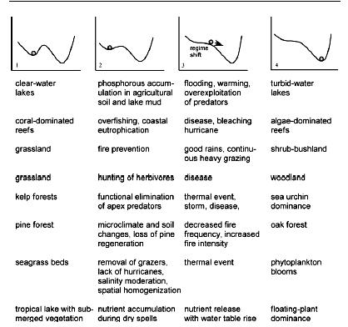

*Fig. 9 Examples of alternative stable states in different ecosystems (1,4) and the causes (2) and triggers (3) behind the loss of resilience. From: Folke, C., Carpenter, S., Walker, B., Scheffer, M., Elmqvist, T. Gunderson, L. and Holling, C.S., 2004, Regime shifts, resilience and biodiversity in ecosystem management, Annual Rev. Ecol. Evol. Syst, 35, 557 – 581)*

#### 

**BOX 4  
BIODIVERSITY, FUNCTIONAL GROUPS AND RESILIENCE**

Studies of coastal environments and reefs suggest that more diverse ecosystems are less sensitive to disturbance. Also, ecological experimentation and theory supports the idea that ecosystem goods and services, and the ecosystem properties from which they are derived, depend on biodiversity, broadly defined. (Hooper et al. 2005). Therefore, biodiversity appears to be an important factor. The question is what is meant by biodiversity. More recent studies in the field of biodiversity & ecosystem functioning have moved the emphasis from biodiversity in the sense of species richness, towards biodiversity in the sense of (1 *functional groups*; (2) multiple processes and (3) interactions within the wider ecological network (e.g. food web) (Reiss et al., 2009).

Functional groups are groups of species that share the same traits or features.   
In marine biology, functional grouping is traditionally based on morphology. Padilla and Allen (2000), however, indicate that grouping based on a particular function, rather than on morphology, can be very useful for ecosystem-level questions and modeling, especially in cases where there are too many species in a system to consider them individually (Padilla and Allen 2000). Obviously, testing of functions identified should be done before generalizations can be made. Usually, functional groups are identified using statistical methods, such as multivariate analysis (for example Laliberté et al. 2010).  
Within the context of ecosystem functioning, functional groups may be defined as ‘groups of species that share common biogeochemical attributes’. For example, photoautotrophs store light energy as carbon products, whereas decomposers move nutrients between dead organic matter and inorganic nutrient pools (Naeem 1998).  
The persistence of functional groups contributes to the performance of ecosystems (and hence to the generation of ecosystem services). Loss of a major functional group, or addition of even one species of a functional group that is lacking, may cause a dramatic change in the ecosystem functioning. For example in Hawaii, the introduction of the nitrogen-fixing tree *Myricafaya*, where previously no nitrogen-fixing species was present, increased nitrogen inputs up to five times. (Folke et al. 2004 and references therein).  
  
Functional diversity is the variation in responses to disturbances among species that contribute similarly to ecosystem function. Most of the literature on functional types refers to functional response types. This aspect of functional diversity is called response diversity, and is considered crucial for ecosystem renewal and reorganization following disturbances (Elmqvist et al. 2003*)*, therefore for maintaining resilience. Response diversity is seen as the first safeguard against the loss of ecosystem functions and services (Elmqvist et al. 2003; Folke et al. 2004).

Ecological resilience depends on functional diversity, functional redundancy, i.e. the presence of different species for the same function and on response diversity, i.e. how functionally similar species respond differently to disturbance. (Laliberté et al. 2010). Loss of functional groups and their response diversity leads to less resilience. Loss of resilience makes ecosystems more vulnerable to changes that previously could be absorbed.

#### Ecological resilience and scales

Although Building with Living Nature solutions make use of structures and processes that belong to the ecosystem, it will still be important to ensure a proper balance in the ecosystem itself (e.g. an oyster reef), and in the larger “receiving” water system of which the ecosystem itself is a part (e.g. the Eastern Scheldt). Species can operate at different levels of time and space. A BwLN solution, created by introducing or strengthening a specific ecosystem in a larger water system, may have an effect on the larger water system. Systems thinking should therefore not be limited to the ecosystem/BwLN solution itself, but should also include the water system, of which the BwLN solution is a part, as a whole.   
An example are coral reef grazers. Some grazers operate intensively on a small scale from centimeters to tens of meters (mollusks, amphipods, sea urchins, territorial juvenile fish), others feed less intensively, but over larger scales , from hundreds of meters to thousands of meters (e.g. large adult fish), or on very large scales, from hundreds to thousands of kilometers (green turtles). The distribution of grazers in time and space is an important component of response diversity, hence resilience. If we want to take into account functional roles of species that support ecological processes, we need to look at the levels on which they operate. Ignoring this may lead to a mismatches between scales of disturbance and size of the area taken into account for management. (Elmqvist et al. 2003, Nyström, 2006). Figure 9 illustrates this effect for the size of a marine reserve area.

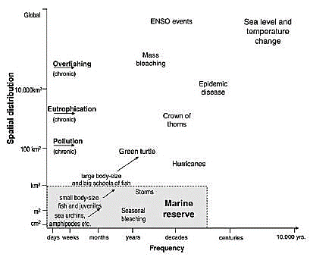

*Fig. 9 Mismatch between scales of disturbance, levels of operation of herbivores and management, showing that disturbance and movement of functionally important herbivores are not necessarily protected by marine reserves. From: Nyström, M., 2006, Redundancy and response diversity of functional groups: implications for the resilience of coral reefs, AMBIO 35 (1), 30 - 35*

# conclusion

Building with Living Nature solutions are resilient solutions; they can adapt to environmental stress factors, such as sea level rise. BwLN solutions are therefore largely self-maintaining. These type of solutions are more flexible than traditional engineering solutions. Moreover, these type of solutions are integrated and sustainable solutions that fit into modern Integrated Coastal Zone Management.

Building with Living Nature solutions make use of the effect of the ecosystem in question. E.g. artificial oyster reefs in the Eastern Scheldt stabilize sediment. Another way of formulating this is using the concept of ecosystem services. Flood protection is an example of such an ecosystem service. Every ecosystem supplies multiple ecosystem services. Creating or restoring an ecosystem will therefore automatically strengthen the ecosystem, and therefore also strengthen other services supplied by the ecosystem. A BwLN solution will therefore always be multifunctional.

Additional services can be used for obtaining public support, especially when these additional services are recreational services, or production services. Here, care should be taken to find the balance between using and overusing the system.

The approach also has its limitations: BwLN solutions are not as robust as traditional engineering solutions. In most cases, combinations with additional safety structures need to be designed, creating a zonation of several building blocks.

### designing building with living nature solutions

Building with Living Nature designs are to take the following issues into account:

* Identification of use that is made of the available space locally, taking into account all interests of stakeholders
* Identification of the appropriate building blocks for the local situation, and identification of a suitable ecosystem, that fits into the biogeographic zone. Building with Living Nature solutions should take the natural zoning of the coastal system as a point of departure: the location where the ecosystem selected is inserted/restored should be seen as one of the design criteria for the solution. This requires a thorough knowledge of not only the ecosystem selected itself, but als of the coastal system in question. And this will be location-specific knowledge. For example, in a situation such as the Eastern Scheldt, where artificial oyster reefs are used, much can be learnt from the location of natural oyster reefs in the system. Zones that are suitable for artificial oyster reefs in the Eastern Scheldt, are not always also suitable for artificial oyster reefs elsewhere. In this zonation approach, a series of structures are used for flood protection.
* Identification of the factors that control the desired ecosystem function; design of the solution should be based on both biotic and abiotic factors. Attention should be paid to both ecological and engineering design criteria. Design criteria are often focusing on the desired effects, such as wave breaking, wave dissipation, sediment stabilization. These can be seen as engineering design criteria. The materials used, however, is a living structure. Therefore, the design should also take (1) habitat requirements into consideration, criteria that focus on the establishment and persistence of the ecosystem in question and (2) identify the controlling factors for the desired ecosystem function (e.g. wave attenuation, or sediment capture, or sediment stabilization) that is the basis for the desired ecosystem service (e.g. flood safety). The ultimate design of a Building with Living Nature solutions asks for a combination of both engineering and ecological design criteria. Here, use should be made of knowledge generated in the field of Resilience research.

### research gaps

* So far, the design of BwLN solutions has been focusing on effects of the BwLN solution, i.e. the engineering design criteria. Additional focus should be put the factors that control the desired ecosystem function, i.e. the ecological design criteria for the ecosystem function in question
* More attention can be paid to the balance between a stabile, robust solution and a flexible, resilient solutions. This will depend on the options offered in/by the local situation. In this respect, it can be considered to develop decision support system.
* A field that needs more exploration, is the effects of implementing BwLN solutions on the coastal system as a whole, in terms of on carrying capacity , resilience (indicators, tipping points, thresholds). Also, BwLN solutions create additional values. A negative side- effect could be over-use of these additional values, and consequently passing thresholds for resilience,
* The frame of reference should be larger that the BwLN solution and its direct effect. This also effects the area that should be included for monitoring BwLN solutions
* BwLN solutions may lead to more opportunities for invading species. E.g. more oyster reefs in the Eastern Scheldt also mean more hard substrate instead of soft substrate, favouring different species.
* BwLN create additional values, in other words, additional ecosystem services. These additional values can also be given a monetary value, which can be of use in the cost-benefit analyses, also within environmental impact assessments.

# literature list

Barbier, E.B., Hacker, S.D., Kennedy, C., Koch, E.W., Stier, A.C. and Silliman, B.R., 2011, The value of estuarine and coastal ecosystem services, Ecological Monographs 81 (2), 169 – 193

Beamont, N.J., et al., 2007, Identification, definition and quantification of goods and services provided by marine biodiversity: implications for the ecosystem approach, Marine Pollutions Bull. 54, 253 – 265

Borsje, B.W. et al., 2011, How ecological engineering can serve in coastal protection, Ecological Engineering, 37 (2), 113- 122

Brown, C. et al. (eds), Marine and coastal ecosystems and human well-being: a synthesis based on the findings of the Millenium Ecosystem Assessment, UNEP 2006

Costanza R. et al. 1997, The value of the world’s ecosystem services and natural capital, Nature 387, 253 – 260

Davic , R.D., 2003, Linking keystone species and functional groups: a new operational definition of the keystone species concept, Conservation Ecology 7(1), r.11 [online], URL:<http://www.consecol.org/vol7/iss1/resp11>

De Groot, R.S., Wilson, M.A., Boumans, R.M.J, 2002, A typology for the classification, description and valuation of ecosystem functions, goods and services, Ecological Economics 41, 393–408

Diaz, S. and Cabido, M., 2001, Vive la difference: plant functional diversity matters to ecosystem processes, Trends in Ecology and Evolution 16 (11), 646 - 655

Elmqvist, T., Folke, C., Nyström, M., Peterson, G., Bengtsson, J., Walker, B. and Norberg, J.,

2003, Response diversity, ecosystem change, and resilience, Frontiers in Ecology and Environment 1 (9), 488 - 494

Folke, C., Carpenter, S., Walker, B., Scheffer, M., Elmqvist, T. Gunderson, L. and Holling, C.S., 2004, Regime shifts, resilience and biodiversity in ecosystem management, Annual Rev. Ecol. Evol. Syst, 35, 557 - 581

Holling, C.S., 1996, Engineering resilience versus ecological resilience, in: Gunderson, L.H., Allen, C.R, and Holling, C.S. (eds.), 2010, Foundations of Ecological Resilience, Washington: Island Press

Hooper, D.U. et al., 2005, Effects of biodiversity on ecosystem functioning: a consensus of current knowledge, Ecological Monographs 75(1), 3 – 35

Koch E.W. et al. 2009, Non-linearity in ecosystem services: temporal and spatial variability in coastal protection, Frontiers in Ecology and the Environment 2009; 7(1): 29–37

Laliberté, E., et al., 2010, Land-use intensification reduces functional redundancy and response diversity in plant communities, Ecology Letters 13, 76 – 86

Millenium Ecosystem Assessment, 2005, Ecosystems and Human Well-Being: Synthesis, Island Press, Washington D.C.

Naeem, S., 1998, Species redundancy and ecosystem reliability, Conservation Biology 12 (1), 39 – 45

Nyström, M., 2006, Redundancy and response diversity of functional groups: implications for the resilience of coral reefs, AMBIO 35 (1), 30 – 35

Olenin, S. 1997, Benthic zonation of the Eastern Gotland Basin, Baltic Sea, Neth.J. of Aq.Ecol. 30 (4), 265 – 282

Olenin, S., 2011, Functional ecology of marine biotopes: an introduction to the biological and ecological structures and the functions of biodiversity in different parts of the Baltic Sea, PREHAB PhD course, Klaipeda University, Lithuania

Padilla, D.K. and Allen, B.J., 2000, Paradigma lost: reconsidering functional form and group hypotheses in marine ecology, J. Exp. Mar. Biol. Ecol. 250, 207-221

Reiss, J., Bridle, J.R., Montoya, J.M. and Woodward, G., 2009, Emerging horizons in biodiversity and ecosystem functioning research, Trends in Ecology and Evolution,24 (9), 505 – 514

Slear, G. , 2012. Environmental Concern (EC) and the restoration of living shoreline. Website used on 4-2-2013: <http://www.wetland.org/restoration_livingshorelines.htm>

TEEB 2010, The economics of ecosystems and biodiversity: ecological and economic foundations, United Nations Environment Programme/Earthscan Ltd, London

Waterman, R.E. 2008, Integrated Coastal Policy via Building with Nature, Delft 2008

1. For sea grass, aboveground biomass is lowest in the tropics in summer, increases at mid latitudes (20⁰ – 30 ⁰), decreases again between 40⁰ and 50⁰, and is highest at 60⁰ (Koch et al. 2009).