|  |
| --- |
| **Building with Nature** |
| From concepts to practice |
|  |
|  |
|  |
| **Hong Tao**  **Stu.No. 40777** |
| **2011/6/5** |
|  |

Contents

Abstract 3

1. Introduction 4

1.1 Building with nature in Deltas 4

1.2Research questions 7

1.3Research method used 8

1.4 Structure of this report 9

2. The “Building with nature” approach 9

2.1History 9

2.2“Building with Nature” way of thinking and acting 10

3. Representative cases description 11

4. Conceptual Framework 48

4. 1. Components of design 48

4. 2. Ecosystem engineering species and time used 50

4. 3. Function analysis 54

4. 4. Water system 57

5. Chinese experience with integrating management approach 60

6. Conclusion and recommendations 61

7. Reference 62

# Abstract

A research project aimed to investigate suitable methods to classify the characteristic aspects of *Building with nature*. The research took place from October2010 to February 2011.

The research is focused on the concepts of Building with Nature which is dealing with development and management in deltaic areas. The history and experiences of building with nature will be analyzed. Furthermore, the emphasis of this report lies within the characteristics of each case.

Hence, this analyzing report of cases which includes Dutch and projects in other countries is carried out by classifying characteristics of building with Nature concepts. Then a conceptual framework is built up. Recommendations on how to get a better implementation of the concept *Building with Nature* are described.

This report describes how to put the concept into practice and to make use of cost-effective techniques and create added value for each application. Therefore, recommendations are described and possible suggestions are highlighted.

# Introduction

The Delta Academy in the Netherlands is developing applied knowledge to help maintaining the safety and economic, social and natural values of Delta areas. *Building with nature* approaches is applied to use not only natural materials but also natural processes and interactions in order to achieve an ideal situation for the benefit of safety against flooding and erosion. The concept also strives to use ecosystem functions to favor food production, freshwater security and sustainable livelihoods. A lot of experience is available worldwide in the field of *Building with nature*. Knowledge and lessons learned are paramount to effectively help *Building with Nature* projects to address international, national and regional issues in adaptive management. This will enhance the development of water management issue in delta areas.

## 1.1 Building with nature in Deltas

#### 1.1.1Challenges for Delta areas

The delta area is a dynamic area of natural change and of increasing human use. Deltas occupy less than 15% of the Earth's land surface; yet accommodate more than 50% of the world population (it is estimated that 3.1 billion people live within 200 kilometers from the sea). It is also expected that three-quarters of the world population will reside in the delta area by 2025[3]. Thus human activities originating from this small land area will impose an inordinate amount of pressures on the global system. Coastal zones contain rich resources to produce goods and services and are home to most commercial and industrial activities. In the European Union, nowadays almost half of the population lives within 50 kilometers of the sea and coastal zone resources produce much of the Union's economic wealth. The fishing, shipping and tourism industries all compete for vital space along Europe's estimated 89 000 kilometers of coastline, and coastal zones contain some of Europe's most fragile and valuable natural habitats. Due to global warming, sea level rise has occurred at a mean rate of 1.8 mm per year for the past century, and more recently, during the satellite era of sea level measurement, at rates estimated near 2.8 ± 0.4to 3.1 ± 0.7 mm per year (1993–2003) [8]. Protection against the sea level rise in the 21st century will be especially important, as sea level rise is currently accelerating. In the last decades the coastal defense system is no longer stressed with inflexible solid bulwarks, like dams and dikes, but instead on flexible soft structures in harmony with the sea, like dunes and beaches. Integrating ecosystem functions and human activities in coastal areas is becoming more and more popular recently. The method of Building with Nature should be emphasized, both from the viewpoint of nature development and from the viewpoint of creating added value. The emphasis is on sustainable development in densely populated coastal and delta areas. Moreover the integration of problems in multifunctional solutions in delta areas will be the first step towards realization of harmonic and prosperous living for humans. All deltas around the world face great challenges in solving these problems.

#### 1.12Integrated Coastal Zone Management (ICZM)

Integrated coastal zone management (ICZM) is a process for the management of the coast using an integrated approach, regarding all aspects of the coastal zone, including geographical and political boundaries, in an attempt to achieve sustainability. In order to establish sustainable levels of economic and social activity in the delta areas, the protection of coastal environments gets involved in the development, management and use of coastal functions. An optimal balance between environmental protection and the development of economic and social sectors is paramount [2]. In the coastal environment there is a dynamic relationship between many processes all of which are interdependent. A long-term perspective will take into account the precautionary principle. Adaptive management involves the integration of design, management, and monitoring to systematically test assumptions in order to adapt and learn the development of problems. Working together with natural processes while respecting the carrying capacity of the ecosystem will make human activities more environmentally friendly, socially responsible and economic effective.

The integration in coastal zones can be defined as 5 types of integrations***:***

***Integration among sectors***

There are many sectors that operate within the coastal environment. These human activities largely have an economic purpose such as agriculture, recreations, fisheries, logistics, industry and other developments. A sense of co-operation between sectors is the main requirement for sector integration within ICZM. This comes from the realization of a common goal focused on sustainability.

***Integration between land into water and water into land in the coastal zone***

This is the realization of the physical and biological environment being a whole. The coastal environment is a dynamic zone where many interdependent processes take place. The link must be made between changes in the system.

***Integration among levels of government***

Between levels of governance, consistency and co-operation is needed throughout planning and policy making. ICZM has a common purpose at local, regional, and national levels. Common goals and actions increase efficiency and mitigate confusion.

***Integration between nations***

ICZM is as an important tool for water management on a global scale. If goals and beliefs are common on a supranational scale, large scale problems could be mitigated or avoided.

***Integration among disciplines***

Throughout ICZM, knowledge should be accepted from all disciplines. All means of scientific, cultural, traditional, political and local expertise need to be taken into account.

The term integration in a coastal management context has many horizontal and vertical aspects, which reflects the complexity of the task. Management must embrace a holistic viewpoint of the functions that make up the complex and dynamic nature of interactions in the coastal environment. To achieve the principles set out in sustainable types of management a step by step process can be divided into:

Firstly, issues and problems need to be identified and assessments of these need to be quantified. This first step will include integration between government, regional authorities and local residents (public support). That means once the issues and problems have been identified and weighted, an effective management plan can be made. The plan will be specific to the area in question.

Secondly, the adoption of the plan can be carried out. They can be legally binding statutory plans, strategies or objectives which are generally quite powerful or they can be non-statutory processes and can act as a guide for future development.

The third step is implementation, this active phase includes: law enforcement, workshops, development etc.

The last phase is evaluation of the whole process. ICZM is an ongoing process which should constantly readjust the equilibrium between economic development and the protection of the environment.

#### 1.13Building with nature (BWN)

One important method that can be used in ICZM is the principle of building with nature. *Building with nature* approaches to building use not only natural materials but also natural processes and interactions in order to achieve a flexible integration of land and water, materials, ecosystem, and other surrounding conditions. It is also a positive approach to use natural processes which can lead to a sustainable development of areas benefiting as well the nature in that area. The method of Building with Nature should be emphasized, both from the viewpoint of nature and from a viewpoint of cost-effectiveness. Human activities should be incorporated as much as possible in the system of natural cycles. The idea behind this is to reduce as much as possible the negative effects of using the ecosystem.

Depending on the types and shapes of the coastal line, the forces and interactions that can be used by the method *Building with Nature* are: Tidal action (ebb & flood); Wave action (specifically in the breaker zone) and swell action; Sea currents other than tidal currents; River outflow (as a force and as a supplier of freshwater and sediment); Gravity; Wind; Rain; Solar radiation; Interaction dunes-vegetation (root systems of the vegetation hold together sand and silt); Interaction coastal zone-mangroves; and last the Complex interaction between marine organisms and sand/silt/clay particles in beach and near shore[1].

With the concept of *Building with nature*, at the new flexible dynamic designed coastline accretion and erosion are more or less balancing each other. Maintenance of the whole system is based on the natural forces and human activities such as periodic beach nourishment. Another important factor is that the method is applicable in many coastal regions globally and has been applied with success, adapted to local situations.

## 1.2Research questions

The present research report aims at analyzing different projects concerning *Building with nature*. In order to do so, the research questions are focused on the following aspects:

1. What are the concepts of *Building with Nature*?

Concepts mentioned in the representative examples have been considered for using in practice.

1. What are the characteristic aspects of building with nature (physical or biological) according to different situations?
2. How have BWN concepts been used in different projects and how will it be (or has it been) implemented?

*Building with nature* is one of the main concepts that approaches water management at the global scale. An evaluation for the application of the *Building with Nature* concept in the worldwide water sector is made based on analyzing international projects. Thus, to answer these questions, the research is focused on the development of *Building with Nature* concepts and solutions for practical application by analyzing current projects. While the concepts of *Building with Nature* have been carried out, the function of different cases will be analyzed. In addition, creating added value becomes essential in applications. In the next chapter of this research, a conceptual framework will be build up by four criteria which are following:

The first criteria describe the ideal design with all components, which includes both physical and biological aspects. This indicates material has been used in the design.

The second one is focused on analyzing the ecosystem engineering scale and time used in practices. This is an important measurement in the concept of BWN.

The third aspect aims at stakeholder analysis and is more specifically focused on applied functions. This is another factor for BWN.

The last one is about water system analysis which refers to the salinity of water body. This indicates how BWN concepts have been applied in what kind of water system.

Taking into account the complexity of the research questions it seems to be appropriate to concentrate on added value of different cases. The selected cases had to comprise essential functional components in the design as well as include a selection of other characteristics that are representative for the concept *Building with Nature*.

Therefore, summaries are described and recommendations about future planning are given.

## 1.3Research method used

**Literature review**

The used method is reviewing related works about the concept *Building with Nature* (definitions, explanations, justifications), reviewing previous articles related to Eco-Dynamic development and design (definition, explanations and implementation) and reviewing principles and methods of ecological engineering relating to results (particularly in reality). This gives an overview of the main concepts and experiences of building with nature related to water management.

**Information collection**

The information for the research was collected from different case studies and by interviewing main players from ecological engineering sectors which are related to *Building with nature*. In both ways, the researcher was supervised by Hogeschool Zeeland. Internet research for different cases which focus on projects about coastal ecological engineering in both national and international scale has been done.

**Information (cases) analysis**

The information has been analyzed in two phases. First, the case study is described. This includes different functions, socio-economic development and important lessons learned. Then, horizontal analyses and comparisons of different cases are figured out. Finally, detailed analysis and recommendations are given about the *Building with Nature* concepts and its applications.

**Research Criteria**

The research criteria are basically divided into two parts. The first one is about selection of cases; the second one is talking about the analysis of cases. Both of them are based on the concept *Building with Nature*. Selection of the cases is following the concept *Building with Nature* which is either using natural materials and natural forces or interactions in order to achieve a flexible integration of land and water, materials, ecosystem, and other surrounding conditions. Analysis of the cases is concerning the integration approach of different cases which are divided into four aspects which are explained in 1.2.

## 1.4 Structure of this report

The concepts of *Building with Nature* are emphasized by analyzing the challenges in delta areas and studying the history of the concepts. Then, both national (Dutch) and international cases are selected and analyzed. In the following report the conceptual framework is presented. Since the researcher is a Chinese student, the researcher thought it was a great opportunity to use Chinese experiences in integrating concepts of Building with Nature into coastal zone management, in order to brighten the views and probably gain insights and inspiration for new and unconventional solutions in other cases. Finally, the detailed recommendations based on analyzing framework of different cases are described and conclusions are submitted.

# 2. The “Building with nature” approach

## 2.1History

*Building with nature* is a relatively new concept and is based on the principle that measures engineering for optimal use of the ecological dynamics and functions. On the one hand, this measure has to fit the natural process. On the other hand, the win-win solution and cost-effective technique would be emphasized. The history of *Building with nature* starts with the concept of ecological engineering in 1962 and evolutes in around 50 years till now.

The term ecological engineering was coined by Howard T. Odum in 1962 and has since been used extensively in the North America, Europe, and China [4]. Odum elaborated in his book System Ecology that “the engineering of new ecosystem designs is a field that uses systems that are mainly self-organizing.” Parallel to this, the term "eco-engineering" was introduced in China in 1960s. This was mainly used in the wastewater sector. Qi and Tian two Chinese experts in eco-engineering (from 1988 to 2003) expand the knowledge by stating ecosystem design, the main task of ecological engineering, could be used for global scale problems. In Central Europe and the U.S. the idea of eco-engineering, eco-management also start to gain a foothold, and with the establishment of the journal "Ecological Engineering: The Journal of Eco-technology" it became available in 1992 for a large public scale (Mitsch& Jorgensen 2003) [5].

The book "Design with Nature" by Ian McHargin 1969 is one of the first works that addresses the relationship between land use and ecology. The original idea was predominantly anthropocentric, and assumed that man is superior to nature. McHarg also features an eco-centric idea that the humans are part of nature. This book therefore is the foundation for *Building with Nature* and the idea that nature can be integrated in human activities.

Furthermore, the concepts become more and more focused on wetlands and the purification of contaminated water with ecosystem services. The original definition of eco-engineering, however, changed over the years. In 2003, by Mitsch& Jorgensen broader definition was altered into 'the design of sustainable ecosystems that integrate human society with its natural surroundings’.

Later on, the concept of *Building with Nature* was created by the hydraulic JN Svašek in 1979. This method is based on morphological theories and postulates “soft” solutions for coastal defense, focuses on using the materials and forces of nature (Waterman, 1979-2009). Waterman defines the essence of this concept as follows: "Flexible integration of land-sea and in water-in-the-new-country, using existing materials, forces and interactions in nature, which includes existing, potential natural, bio-geo-hydrology and geomorphology of the coastline and seabed [6].

Since the climate challenge is increasing nowadays, the concept *Building with Nature* is dispersed by different methods during the period from 2003 to 2009, such as Rich Revetment (2006), 2007: Bio-builders (e.g. Oyster Reef, Floating Marshes, Afsluitdijk and Wave reducing Eco Dike) (2007), Harbor opportunities in Rotterdam (2009), EU project 'Our Coast' (2009), Ecoshape (2008-2012) Natural climate buffers Structure (2008) and Building with Living Nature (2009). It is clear that eco-engineering related to the concept of *Building with Nature* also contributed to its development. The *Building with Nature* program in the Netherlands focuses specifically on "using the forces of nature to water supply infrastructure to create, while creating opportunities for nature". The biggest difference is therefore taking the worlds' water supply infrastructure [7].

## 2.2“Building with Nature” way of thinking and acting

The geographical location, political infrastructure, financial position and technological development have to be taken into account in applications of concepts *Building with Nature*. However, the underlying knowledge of natural processes and ecosystem functioning and the experience in integrative corporate governance can be applied in various different situations. Applicability is also depending on political stability, national awareness of climate change, the state of infrastructure and local functions (desired) in the area. For example, with the economic development of Port Rotterdam, the ideas of Maasvlakte 2 are applied and can be used in the other situations. Making use of economical urbanizations to aid natural development can be applied widely. But it is very dependent on local commercial development, the state of the ecosystem and the technical ability of water managers. Solutions like a wave reducing eco dike and rich revetment can be used in both a large and small scale and strongly depend on local situations of both the ecosystem and the infrastructures. Then again, the proposal of Afsluitdijk (Nature Driven Design) is applied in a specific situation like IJsselmeer, and can be used in a large scale reorganization or redevelopment of the area. Several aspects typify the Building with Nature way of thinking and acting:

**Thinking of land-use: multi-functional use of space**

The method of Building with Nature is developed primarily for making use of ecosystem functions to increase safety in coastal, river and urban areas, and also aims at optimizing function combinations to enhance natural values, recreation, freshwater security and livelihood. But ecologically optimizing multi-functional use of space needs plenary knowledge and tools from delta managers.

**Thinking of material-use: multi-functional use of material and the ecosystem**

The ecosystem in the current situation is paramount for designing and planning the whole project. The design strongly depends on local environmental conditions. Dynamic behavior of water, sand and natural materials should be incorporated in creative and new solutions.

**Acting in integrated way: create added value for occurring situation**

Different functions, needs and wishes are integrated by combining stakeholders. Integrating ecosystem functions in *Building with Nature* approaches can be cost-effective, benefit safety, nature and livelihoods. Working together with nature requires time and space for nature to develop. Project management requires integrating corporations between different stakeholders and government. Added value e.g., navigation, recreation, fishery, agriculture and so on are created during the process of management.

# 3. Representative cases description

The principle of *Building with Nature* is defined by Mr. Waterman, mentioned before in the report, as flexible integration of land-in-sea and of water-in-the-new-land, making use of Materials, Forces & Interactions present in nature, taking into account existing and potential nature values, and the Bio-geomorphology & Geo-hydrology of the coast and seabed. [6] Regarding the land reclamation application, the definition of Building with Nature should be emphasized, both from the viewpoint of nature and from a viewpoint of cost-effective techniques. Coastal functions should be incorporating as much as possible in nature. The concept is applicable in many of the coastal regions such as the Netherlands and has been applied with success and adapted to local situations.

The definition of *Building with Nature* should be made available for application worldwide, in such a way that relevant perspectives and options for action can be provided, which should be designed for local circumstances. This chapter aims to provide structured representative cases concerning *Building with Nature*. Information has been collected through a review of literature and interviews with experts from different partners (government, knowledge institutes, universities and private companies). The chapter is not a complete list of projects. However it contains the ones in the Netherlands and also on international scale, in which ecologically optimized multifunctional use of coastal area takes place. And not all of the cases have been realized yet. Useful lessons learnt from these cases give a better understanding for definitions of *Building with Nature*, as well as added value for other applications worldwide.

#### 3.1Representative Dutch cases

The Netherlands are a low lying deltaic area, largely below sea level. But the Dutch people are famous at water management in the past decades, and dealing with the climate change is the most important issue in the world in this century. Riverbeds are largely altered and dammed. The safety largely depends on dams, levees, dikes and dunes.

The most important effect of climate change is sea level rise, an increasing river discharge in winter and a decreasing river discharge in summer. Most climate scenarios predict a higher frequency of extreme weather events like more severe storms, soil droughts and high amounts and intensities of rainfall. These effects also lead to other indirect effects. For example, the safety standard against flooding is decreasing; salt intrusion and desiccation of nature land are increasing. That is why infrastructure, agriculture, industry, nature and fresh water supply are influenced by climate change as well. Recently, governmental and knowledge institutes in the Netherlands have realized the limitations of traditional hard structures which are not ecological sustainable and aimed at finding ways to deal with the climate threats in a sustainable way: optimizing natural functions of coastal systems. This has led to the development of combinations of soft and hard structures in which natural functions play an essential role. It is also based on the idea: making use of natural process in order to increase safety and enhance or maintain ecosystem functions by cost-effective techniques.

Although these ideas are originally from Holland and designed for some Dutch situation, there are also opportunities for other countries to put the concepts into applications. And these must be also useful for analyzing the concept itself. Thus, lessons learnt from Dutch representative cases can be very valuable for this research.

This chapter gives ideas of important, well known, highlighted and widely applied Dutch cases in the Netherlands. And they are all focused on coastal and river safety against flooding. Moreover, the goal of these cases is to use the natural system to adapt to climate change and furthermore is changing climate by nature system itself.

**Case 1 Classic Dutch coastal nourishment**

The classic Dutch method concerning *Building with Nature* is based on theory and practice, the emphasis is no longer placed on bulwarks against sea, but instead on acting in harmony with the sea. The method aims at creating a flexible, dynamic, equilibrium coast consisting of dunes and beaches in which accretion and erosion are more or less balancing each other, with a limited maintenance factor in the form of periodical beach nourishment, and a minimum of solid seawall elements involved. The example is the Dutch coastline from Rotterdam to Den Helder.

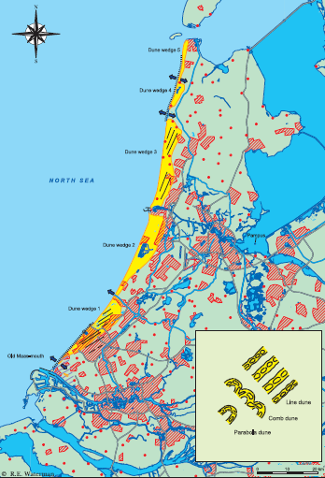

Fig 1 location of classic Dutch coastal sand norishment

|  |
| --- |
| Main idea: Classic nourishment of sandy beach along the Dutch coast  Added value: Combining safety, nature and recreation function by Building with Nature  Developed and coordinated by: RWS, Province North and South Holland dredging companies  Material used (physical) : sand, concrete integrated  Material used (biological): none  Water system: sea water  Function: emphasize safety, natural and recreation value  Time and Space: Mega-scale and 5 to 10 years  Reference: Waterman, R. E. (1980-2008) Integrated coastal policy via building with nature, **P120** |

**Case 2 Salt Marsh, Groningen and Friesland**

Salt Marshes are pieces of land directly bordering shallow tidal areas and they are bare of dunes and dikes. It will be flooded with seawater during extremely high water levels. Sand and mud particles suspended in the seawater can then subside. The particles fall between the vegetation and do not easily wash away. In this way, salt marshes gradually expand and grow higher. The salt marshes along the coast of Groningen and Friesland were created artificially. The figure below present the location and images of marsh land in Groningen. By building small dams from twigs and soil, the silt from Wadden Sea settled in between. Then, a taller dike would be built around when the salt marshes were high enough. So the land could be utilized first as a grazing area and later as fields for agriculture. The new formed salt marshes gave extra protection to the earlier dammed up grounds. This technique with twigs dams is being applied to prevent existing marshes from disappearing. This is a representative example of concept *Building with Nature* along Dutch coast.

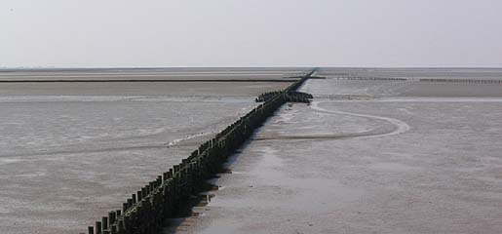

Fig 2 salt marsh land in Groningen

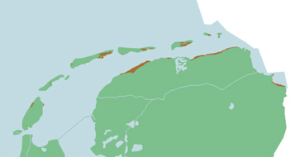

Fig Locations of salt marsh in Groningen and Friesland

|  |
| --- |
| Main idea: increasing the safety by using natural materials (salt marshes)  Added value: Combining safety and nature by using natural materials  Developed and coordinated by: Provinces of Groningen and Friesland and Wadden Academy  Material used (physical) : soil  Material used (biological): salt marshes  Water system: sea water  Function: emphasize safety and natural value  Time and Space: Mega-scale and >10years  Reference: http://www.seaonscreen.org/vleet/content/eng/salt-marshes.htm |

**Case 3: Eco-Concrete**

Building breakwater is a common method for sea defense. The breakwaters at the entrance of the North Sea Channel at IJmuiden, The Netherlands protect the hinterland against wave attack. The breakwaters consist of regularly placed 2x2m concrete blocks. The picture below shows the substantial concrete blocks. The blocks surfaces, and cracks and spaces between these blocks are habitats for a diversity of marine flora and fauna like algae, insects, crabs, shellfish, fish and birds. Because of this, it is important that after renovation of the breakwaters, the ecological system will recover quickly. The new method is using Concrete blocks with eco-friendly toppings. The surfaces of these blocks have various textures and geometric shapes, which stimulate fast and diverse colonization by macro-algae and macro-fauna.

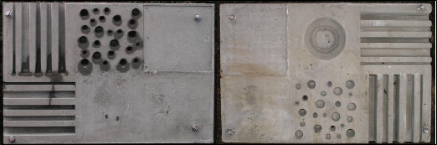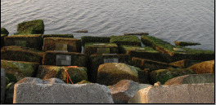

Fig Different texture example of concrete blocks Fig Concrete blocks in reality

|  |
| --- |
| Main idea: Create diversity for breakwaters by using eco-concrete blocks  Specific Challenge: Finding new methods to shape concrete blocks for creating more biodiversity  Developed and coordinated by: Deltares, Ecoconsult, BAM DMC, RWS Noord Holland, Microbeton, C-Fix  Material used (physical) : different shapes of concrete blocks  Material used (biological): none  Water system: Brackish marine, tidal  Function: emphasize nature value and safety  Time and Space: Micro-scale and <5 years  Reference: Deltares, Public wiki, 9/2/2011 |

##### Case 4: Rich Revetment

The traditional hard coastal defense structures like dikes, harbor extensions, piers, dams and groynes are inevitable due to the hard safety requirements (human used) and space or time limitations. But the biological monitoring shows that these structure provide valuable and diverse species communities for the ecosystem. So it is a challenge to design a method that both defense functions have been used and ecological functions are implemented and improved. The concept of Rich Revetment aims at optimizing ecological value in addition to the main civil engineering objectives. Moreover, the objective of the design is to improve biodiversity and bio-productivity for the organisms living on and under the water level. The testing eco-basins were constructed along dike sections near Yerseke and Wemeldinge (see Fig. 6), the Netherlands.

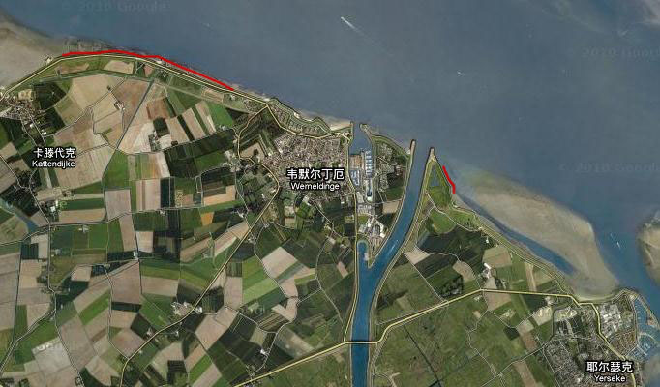

Fig Location of Rich Revetment

|  |
| --- |
| Main idea: Ecological optimizing (design, slope, material and shape) the coastal defense structure to improve biodiversity and bio-productivity  Added value: Combining safety functions and nature development  Specific Challenge: Make a sustainable design to optimize safety in a cost-effective way  Developed and coordinated by: Deltares in cooperation with several public partners (developers and dredgers) and harbor authorities  Material used (physical) : different shapes of concrete blocks  Material used (biological): none  Water system: brackish marine, tidal  Function: emphasize safety and natural value  Time and Space: Micro-scale and <5 years  Reference: Deltares, Public wiki, 14/12/2010 |

**Case 5: The Maasvlakte2 (+ecological mining pit)**

The concept of **(5a) Maasvlakte2** is land reclamation, nature compensation, impeccable logistic chains, recreation areas and economical approaches. The whole area consists of 2,000 hectares into the sea. In the first stage of construction, the trailing suction hopper dredgers are continually working on the reclamation work. These vessels will transport sands from the offshore extraction site to create the new land along the coast. Then the overall sea defenses constructions will be emphasized. The hard seawall will be approximately 3.5km long and consist of a stone-covered dune, paved by a pebble beach. This will be satiated behind a low concrete block dam resting on a multilayer foundation of marine building stone. A total number of 20,000 concrete blocks will be used to construct the seawall. The soft part is around 7.5km long beach with dunes. Focusing on the implementation of integrated costal zone development concerning *Building with Nature*, Maasvlakte 2 is a reclaimed new harbor which has to compensate the loss of nature with the realization of protection area of 25,000 ha along the Dutch coast, an area of up to 35 hectares (including the buffer zone) of new open dry dune, wet dune valley adjacent to the coast and an area of 750 hectares new nature and recreation area. The picture below shows the future image of Massvlakte2. Step by step expansion of most important harbors is taking place, coupled dredging with land reclamation plays a role in the project. Another part of the Maasvlakte 2 project is **(5b) ecological mining pit** method. Sands for construction are dredged from place which is 10 to 11 kilometers away from shoreline.

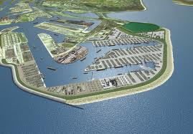

Fig Overview of Maasvlakte 2

The concept of ecological landscaping in sand mining pits is inspired by terrestrial infrastructure projects, where ecological engineering has almost become a standard component of licensing procedures for sand and gravel mining operations. Developing a similar approach in the marine environment may facilitate social and political acceptance of future dredging works, thus accelerating licensing procedures and project realization. The overall aim of the landscaping is to make the pit attractive to a variety of benthos and flora that in turn attract fish, mammals and birds. This is done by creating ideal settlement and habitat circumstances by way of different bed forms and/or combinations of sediment characteristics. This will ensure an increase the biodiversity (volume and type) in the borrow area.  
Ecological landscaping in sand mining areas involves the realization of bed level gradients and other morphological features in newly dredged pits. Whereas present mining policies aim at rapid recovery and restoration of the original habitat on a flat sea bed, the concept of ecological landscaping aims to promote opportunities for nature and economy through development of new, enriched habitats in landscaped mining pits. The feasibility of this concept is derived from recent measurements on the North Sea which reveal a relation between local habitat characteristics and the geomorphology of the sea bed (Baptist et al. 2006). Results show that tidal ridges accommodate different benthic habitats, which are important to both benthic and pelagic organisms. More generally, a zoning exists within geomorphologic features (such as tidal ridges), where the crests give home to poor benthic communities and the adjacent slopes and troughs host benthic communities of higher density and diversity. Fig 8 and 9 shows the difference between traditional design and new design in principle. On the basis of these observations, the application of ecological landscaping in sand mining pits is expected to promote the development of valuable habitats at places where these would naturally not occur, or only on the very long term.

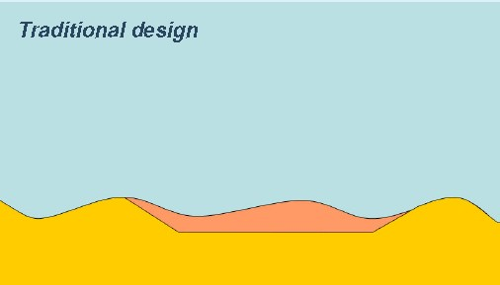

Fig Traditional design of ecological mining pit

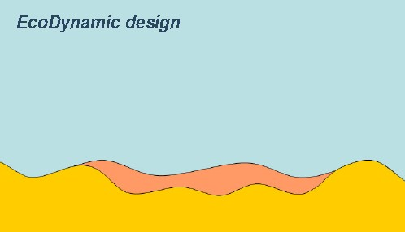

Fig EcoDynamic design of ecological mining pit

|  |
| --- |
| Main idea: Land reclamation, nature compensation, air quality, the impeccable logistic chain, recreation area and ecological landscaping, sand mining, Building with Nature paradigm shift Nature restoration, Environmental monitoring  Added value: Extension port of Rotterdam, land reclamation, combining economical functions, safety and nature development  Specific Challenge: Creating new lands for multifunctional economic value and optimizing safety and nature in a cost-effective way  Developed and coordinated by: Rotterdam harbor authorities in cooperation with several public partners (developers, institutes and dredgers) and Rotterdam city hall  Material used (physical) : sand, different shapes of concrete blocks, steel, pipes, railway and so on  Material used (biological): none  Water system: sea water (North Sea)  Function: emphasize nature, infrastructure, industry, recreation, logistic and safety  Time and Space: Mega-scale and <5 years  Reference: Deltares, Public wiki, 14/12/2010 |

**Case 6: Waddenwerken proposal for Afsluitdijk: Nature Driven Design**

The Afsluitdijk is a major causeway in the Netherlands, constructed between 1927 and 1933 and running from Den Oever on Wieringen in North Holland province, to the village of Zurich in Friesland province, over a length of 32 kilometers and a width of 90 m, at an initial height of 7.25 m above sea-level. It is a fundamental part of the larger Delta Works, a salt water inlet of the North Sea and turning it into the fresh water lake of the IJsselmeer.

In 2007 a project was started by the Dutch government to develop an innovative technical solution for a multifunctional dam that meets the requirements on safety, infrastructure, environment and recreational aspects. In 2010 four concepts have been presented and the selection process is taking place.DHV (Dutch Consultancy Company) developed adaptation plans: Nature Driven Design (Fig. 10) which closes off the Lake IJssel from the North Sea. A buffer zone is created. In one of the plans the Building with Nature concepts is used: Instead of increasing the height of the dike, it will be widened with tidal land with salt marshes.

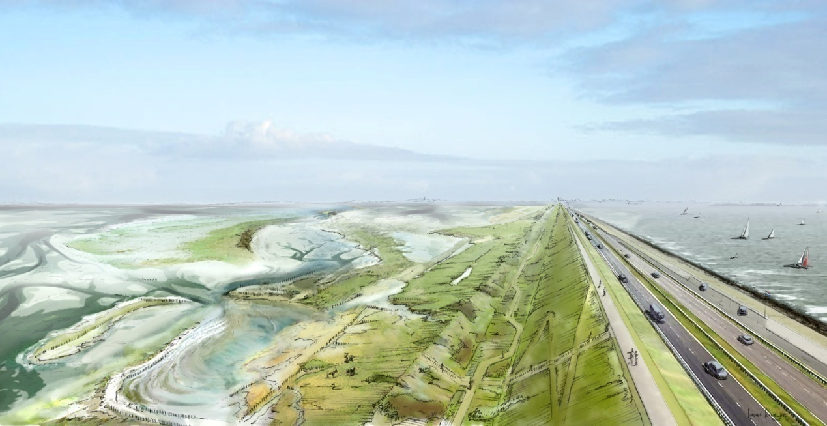

Fig Overview of Afsluitdijk

|  |
| --- |
| Main idea: Widening the Afsluitdijk with tidal land, that naturally reduces waves, grows with sea level rise and creates natural value  Added value: Maintenance of coastal safety which is self-sustaining, with recreation and nature development  Specific Challenge: Increase safety with tidal marshes, which becomes an integrated part of coastal defense  Developed and coordinated by: Deltares, DHV, Alle Hosper, IMARES, Rijkswaterstaat, province Noord-Holland and province Friesland  Material used (physical): sand  Material used (biological): vegetation (salt marsh)  Water system: Brackish water  Function: emphasize natural value, infrastructure, recreation and safety  Time and Space: Mega-scale and 5 to 10years  Reference: Deltares, Public wiki, 14/12/2010 |

**Case 7: Wave reducing Eco Dike**

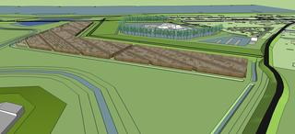The Noordwaard polder is located in the south-western part of the Netherlands. In this area that will be depoldered to increase the discharge capacity of the river, a small area with houses will have to be protected from floodwater. Instead of traditional design of dikes, a lower dike with wave reducing willow-plantations in front of will be built. The strip of willow trees will be 2 kilometer long, 100 meter wide and will effectuate a wave reduction of 80%. In this way the dike can be lower and the nature value is emphasizes.

|  |
| --- |
| Main idea: Incorporation ecosystem functions of a willow forest into the levee design to reduce waves and avoid wave overtopping and enhance safety  Added value: Combining increased safety with cost reduction and minimizing the impacts on environmental quality  Developed and coordinated by: Deltares, WINN, Rijkswaterstaat Room for the River program, Project bureau Noordwaard, Waterschap Rivierenland  Material used (physical): sand and concrete  Material used (biological): willow-plantations  Water system: fresh water  Function: emphasize natural value and safety  Time and Space: Macro-scale and <5 years  Reference: Deltares, Public wiki, 14/12/2010 |

**Case 8: Sand Engine**

An important concept of building with Nature is the Sand Engine (Fig.11). The huge nourishment of 20 million m3 of sand will be deposited along the Dutch Delfland coast, south of the city of The Hague, after which sand, waves and sea currents will naturally disperse the sand. This method will contribute to the coastal safety in a long term and provide additional functions like nature and recreation. The natural formation of the coast will be used. The new design will be implemented a large sand volume (10-20 million m3 or more) and envisage a life span of 20 years. This coastal protection through *Building with Nature* is making the step from defensive design to maximize the potential of the ecosystem. The current project soft sand engine is in the implementation phase. Creating semi natural flood plains in the lake in front of the existing dikes is the idea. These new flood plains enhance security against floods, because of dissipation of wave energy, create new nature areas with conditions for pioneer species and provide the recreation sector with new beaches. The design is based on using wave energy. Sand is supplemented 200 meters before the coast and this sand is transported by waves to the shores, were it is deposited. On the new sediments vegetation grows in order to prevent erosion.

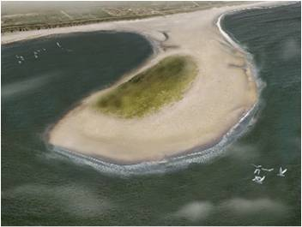

Fig Top view of sand engine

|  |
| --- |
| Main idea: Making use of natural costal process to nourish large scale of coast.  Added value: Combining safety, nature and recreation function by using natural process  Developed and coordinated by: Sand Engine Project Bureau  Involved: Ecoshape, Province of South-Holland, Consultancy firms and knowledge institutes  Material used (physical) : sand  Material used (biological): none  Water system: sea water  Function: emphasize safety and natural value  Time and Space: Mega-scale and >10years  Reference: Deltares, Public wiki, 14/12/2010 |

**Case 9: Room for the River**

Room for the River is a concept that was initiated by the Dutch government and is now fully implemented in Dutch policy programs. Under the behavior of national plan from Dutch government, rivers are given more room to overflow at 39 locations (Fig.12). The room is created by several ways e.g. lowering floodplains, relocation of dikes, depoldering and deepening summer beds. Thus, the restoring parts of historical appearance of the river system (meanders, wetlands). Besides safety, the Room for River program also aims at improving environmental quality: the river region is becoming more attractive and healthy. And the nature and recreation area is livelier.

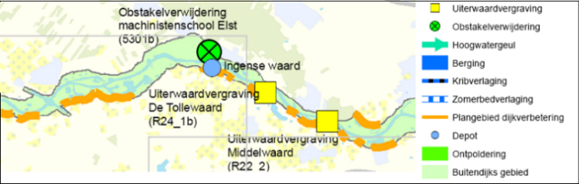

Fig Location of project Room for River

|  |
| --- |
| Main idea: Decreasing the flood risk by give more space to the river.  Added value: Combining increased safety, nature, environmental friendly and recreation function.  Specific Challenge: Creating more space in highly populated area.  Developed and coordinated by: Project Bureau Room for the River  Material used (physical) : none  Material used (biological): none  Water system: fresh water  Function: emphasize safety and natural value  Time and Space: Macro-scale and 5 to 10 years  Reference: Deltares, Public wiki, 14/12/2010 |

**Case 10: Shellfish reef**

Ecological engineering is an important mechanism in shaping ecosystem. Representative examples of ecosystem engineers are oyster reefs and mussel beds (Fig.13), which can not only stabilize the soil but also able to influence the tidal flow and wave action around them. In this way, shellfish reef can modify sedimentation, consolidation and stabilization in estuaries. Using ecosystem engineers to reduce erosion in sensitive areas may provide economic benefits; also contribute to a healthier ecological functioning of the system. The application of shellfish reefs fits in the larger scale of stabilizing measures which starts in the low intertidal and extends to the dike toe. And the shellfish also have potential value for the local economy. For example, the aquaculture industry can invest in the field which creates a win-win situation.

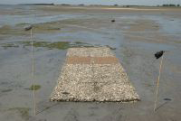

Fig Example of Shellfish Reef

|  |
| --- |
| Main idea: increasing the safety by using natural materials (shellfish reef)  Added value: Combining safety, nature and economic function by using natural materials  Specific Challenge: Design a proper method of shaping shellfish reef for stabilization of dike  Developed and coordinated by: Imares in collaboration with NIOO-CEME and Ecoshape  Material used (physical) : none  Material used (biological): shellfish reef  Water system: sea water  Function: emphasize safety and natural value  Time and Space: Meso-scale and <5 years  Reference: Deltares, Public wiki, 14/12/2010 |

**Case 11: Floating Marsh**

In the hinterland of the Netherlands, levees and dikes are common used for flood safety. In this way, shallow zones and the gradual slope from land to water are lacking. Consequently, species that inhabit these zones are decreasing. In addition, fixed water levels cause erosion of shores. To dampen waves and recreate gradual land-water transitions brushwood mattresses were constructed in front of the dike. These mattresses might facilitate development of floating reed marsh (Fig.14) in the shallow zone in front of a dike. This marsh reduces wave impact on the dike, enhances sedimentation and creates a clear shallow water zone with (submerged) vegetation. Thereby, the initial substrate of the mattress could be suitable for establishment of filter feeders, such as zebra mussels (Dreissenapolymorpha) and other species. This innovative method of brushwood mattresses aims to create floating foundations for emergence of reed vegetation. The floating mattresses reduce currents and waves, thereby decreasing hydraulic loads on the dikes meanwhile creating valuable habitats above or below water. On the other hand, the marshes can be continuously nourished by adding excess material (sand and shells) from sand mining activities to strategically locations. Natural processes gradually distribute these sediments, so natural growth can keep up with the lake level rise. Because of the wave reduction caused by the marshes, wave action near the dike is reduced significantly.

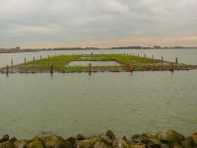

Fig Example of Floating Marshes

|  |
| --- |
| Main idea: creating floating foundations in front of dikes by using natural materials (marshes)  Added value: emphasizing the nature function combining safety  Developed and coordinated by: Deltares in collaboration with Waterdienst and van Schaik  Material used (physical) : none  Material used (biological): vegetation (marshes)  Water system: fresh (brackish) water  Function: emphasize natural value and safety  Time and Space: Macro-scale and <5 years  Reference: Deltares, Public wiki, 14/12/2010 |

**Case 12: Harboring Opportunities**

With the highly development of economic, harbors are often seen as abiotic environment where everything is optimized for economic activities. The concepts *Building with Nature* emphasize the nature value of different functions for many situations. In doing so, the harbors can also provide a habitat for many species. Suspended artificial surfaces can enhance habitat biomass with good water quality. Constructions (Fig.15) made of standard nylon ropes, strategically strung between the piles of a jetty, are a cheap way to do this. Depicted are such ropes four months after they have been installed.



Fig Example of Hulas near the harbor

|  |
| --- |
| Main idea: increasing the biodiversity of the harbor  Added value: Combining economic and nature function by improving environmental quality  Specific Challenge: Design a proper method of more 3-dimensional underwater environment for the settlement of filter feeders  Developed and coordinated by: Deltares in collaboration with Eco consult and Port of Rotterdam  Material used (physical) : none  Material used (biological): filter feeders  Water system: sea water(harbor environment)  Function: emphasize water quality safety and natural value  Time and Space: Meso-scale and <5 years  Reference: Deltares, Public wiki, 14/12/2010 |

**Case 13: Perkpolder**

A busy-ferry line used to operate in Perkpolder (Fig.16) which is located on the coast of Westershelde near Hulst in the Netherlands. Due to construction of a tunnel, the ferry line was shut down and the area was abandoned. By the purpose of reviving the area, a project for renovating economic and environmental function focus on sustainability is carried out. The Eco-dynamic design approach is one in which all three P’s are addressed; the people in terms of improved residential areas, the planet is addressed by creating different natural areas with extra ecological value; and the approach advantages the profit by adding extra economic value to the area, through residential, recreational and commercial activities.

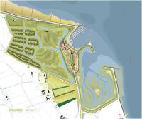

Fig Top view of Perkpolder

|  |
| --- |
| Main idea: Renovating economic and environmental functions of an abandoned dock.  Specific Challenge: Design a proper method for sustainable environment in an abandoned dock.  Developed and coordinated by: Rijkswaterstaat/ Dienst Landelijk Gebied, Royal Haskoning, ComCoast, Province of Zeeland, Hulst municipality, Real estate developers (AM, Bouwfonds Ontwikkeling)  Material used (physical) : none  Material used (biological): none  Water system: brackish water  Function: recreation and residential functions, but emphasize safety and nature functions in the area  Time and Space: Macro-scale and 5 to 10 years  Reference: Deltares, Public wiki, 14/12/2010 |

**Case 14: Galgeplaat nourishment**

The tidal-flat area is rapidly decreasing in the Eastern Scheldt River. Thereby a lot of valuable habitats are lost and erosion on the shoreline is increasing due to the wave action. Sand nourishment is a potential short-term solution to compensate sand lost to tidal channels. To test this innovative approach, Galgeplaat (Fig.17) is nourished with 150,000 m3 of sand dredged from adjacent channels. It is designed as a circle with a diameter of about 500 m and 1 m in height. The location and working method where selected with the aim to minimize the interaction with the commercial mussel beds and to partly cover an existing natural oyster bed.

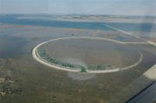

Fig Top veiw of Galgeplaat norishment

|  |
| --- |
| Main idea: increasing the safety and nature value by sand nourishment method  Added value: Combining safety, nature function together  Specific Challenge: Find an optimum in nourishment impact, sand loss and recovery of benthic habitats  Developed and coordinated by: Deltares, RWS  Material used (physical) : sand  Material used (biological): none  Water system: brackish water  Function: emphasize safety and natural value  Time and Space: Mega-scale and <5 years  Reference: Deltares, Public wiki, 14/12/2010 |

**Case 15: Oeverdijk Markermeer**

Because sea level rise, climate change and stronger waves give impacts on dikes, a plan called Oeverdijk is created along the Markermeer. The purpose is to strengthen the Marker Dike between Amsterdam and Hoorn (Fig.18). It is a combination of dike reinforcement with taking ecological measures in a dike bank. A dike through the fresh water is easier to build. Strenghtening the dike with sand fits the rural developments. Nature and recreation can benefit from it. The dike reinforcement between Hoorn and Amsterdam is part of the Flood-protection program which is currently 120 km along the North Sea, Waddenzee, IJsselmeer and Markermeer. The estimated investment amounts to 850 million euros. The project is financed by the government, and different partners got involved along with the province, Rijkswaterstaat, municipalities, interest groups, residents and experts.

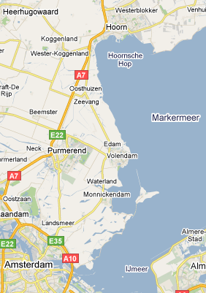

Figure 8 Overview of Markermeer

|  |
| --- |
| Main idea: Strengthen the dike with taking ecological measures in dike bank  Added value: Creating extra, nature and recreation value  Involved: Rijkswaterstaat , Provincie Flevoland  Material used (physical) : sand  Material used (biological): none  Water system: fresh water  Function: emphasize safety, recreation and nature  Time and Space: Marco-scale and <5 years  Reference: http://www.flevoland.nl/nieuws/archief/verbetering-markermeer-ij/index.xml |

**Case 16: Mini Sand Engine Friese IJsselmeerkust**

Because the Delta Commission projects a water level rise of 1.5 meters, the existing dike along the Friesian IJsselmeer coast may not meet future safety levels. Large amounts of sand will be shipped to three pilot locations offshore near Workumerwaard, Oudemirdumerklif and Hindeloopen (Fig.19). The mini soft sand engine means nature can grow with the water level by using small amounts of sand. In this way, the lake shore has been adjusted by the so-called 'soft sand driving force'. In the beginning of 2011, the nature organization Ecoshape starts the first pilot project Frisian Workumerwaard, 25,000 cubic meters of sand dredged from lake is for nourishment. Wind and waves carry the sand gradually toward the coast. And the new coast has potential benefits for recreation. In this way Building with Nature concept applies in practice.

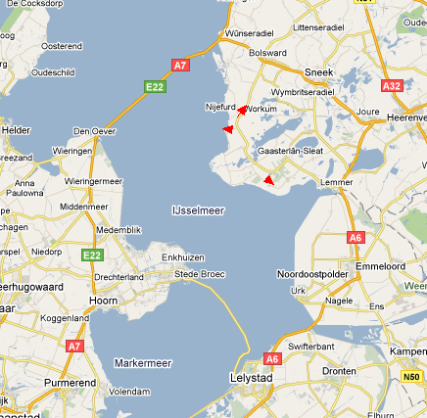

Figure 19 Location of Workumerwaard, Oudemirdumerklif and Hindeloopen

|  |
| --- |
| Main idea: Making use of natural costal process to nourish original coast  Added value: Creating extra, nature and recreation value  Involved: Wetterskip Fryslan, Provincie Friesland  Material used (physical) : sand  Material used (biological): none  Water system: fresh water  Function: emphasize safety, recreation and nature value  Time and Space: Marco-scale and <5 years  Reference: http://www.fryskegea.nl/?artID=688 |

**3.2 Representative international cases**

As mentioned before, the densest areas in the world are situated along coast and on deltas. Not surprisingly, forms of land reclamation can be found in the direct vicinity of these population centers. Representative examples are present nearly all over the world, in Europe as well as in Asia, Africa, America and Australia. These coastal extension cases are primarily cased on safety, industry activities, residential development, logistic chain, tourism recreation, pollution problems, water supply (seawater-desalination), power stations and integrated water resources management.

This chapter gives ideas of important international cases worldwide. And they are all focused on coastal and river functions which integrated with local situations. Moreover, the goal of these cases is also let the nature system to adapt the climate change and furthermore is changing climate by nature system itself.

**Case 17: Wetland Restoration in Wallasea Island, UK**

Wallasea Island situated in Essex, England is bounded to the north by the River Crouch, to the south east by the River Roach, and there are 115 hectares of wetland created on Wallasea island (Fig.20). The wetlands are a compensation area for what was destroyed during harbor development in the 1990’s. Later on the British government ordered a replacement for nature and promoted the use of management realignment strategies. The primary goal is to create bird habitat in the region as the environmental factor. Similar to the Dutch Room for River project, this strategy also plans to give more space to the water by breaching the sea walls and revert land back to water at some parts of area. But in this case, the environmental factors are highly influencing both locations and design. In Wallasea, the location is carefully chosen to have the maximum additional environmental value without destroying any of existing nature. Moreover, the project also aims at shaping the flooding protection region and creating recreation benefits.

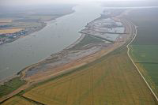

Fig Topview of wetland in Wallasea Island

|  |
| --- |
| Main idea: Restoring wetlands for safety and nature functions.  Added value: Creating recreation value for inhabitants.  Developed and coordinated by: Defra (Department for Environment, Food and Rural Affairs, UK), Environment Agency ComCoast, RSPB (Royal Society for the Protection of Birds, UK), ABP Mer(marine environmental research, UK), Westminster Dredging bv  Material used (physical) : none  Material used (biological): none  Water system: sea water  Function: emphasize safety and natural value  Time and Space: Mega-scale and >10 years  Reference: Deltares, Public wiki, 14/12/2010 |

**Case 18: Le Havre Port + Bird Island, France**

Le Havre is situated in north-western France, on the right bank of the mouth of the river Seine on the English Channel. Its port is the second busiest in France right after Marseille and the fifth largest container port in Europe. Under the project of "Port 2000" the Port Autonomy du Havre was planning a major port extension for container vessels. The purpose of project in Le Havre was to compensate for loss of nature or to even increase natural values. The compensation measures were taken to mitigate and positively influence the environmental effects. A large new container harbor was created in the estuary of the Seine, including breakwaters and an access channel. Moreover, the project included environmental compensation measures to minimize the effects on the environment. These included the creation of mudflat, bird habitat and rerouting of the infrastructure through less ecological vulnerable areas. Also the port design (Fig.21) and construction were adapted to meet environmental requirements. The most representative measure is the bird island design (Fig.22), an island that serves as a bird habitat. The bird island was constructed south of the Le Havre port extension, on a sandbank called "Banc du Ratier" which is situated on the opposite side of the river Seine and the access channel. The island was reclaimed with dredged material from the extension of the approach channel to the port. Moreover, the hard rock revetment, within the sediment rich estuary, provided a different habitat for aquatic life. The design is taking into account the habitat required for different sea birds and with a minimal effect on the current flow of the Seine estuary.

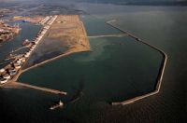

Fig 21 Top view of La Havre Island

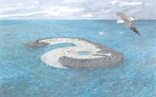

Fig The bird Island

|  |
| --- |
| Main idea: Enlarging the port by creating nature compensation area to minimizing ecological risk.  Added value: Creating extra nature value for the port.  Developed and coordinated by: Boskalis, Dredging International and Atlantique Dragage  Material used (physical) : sand, concrete (integrated)  Material used (biological): none  Water system: sea water  Function: Nature, infrastructure and logistic  Time and Space: Mega-scale and >10 years  Reference: Deltares, Public wiki, 14/12/2010 |

**Case 19: Kansai International Airport, Japan**

Kansai lies in the southern-central region of Japan. Kansai International Airport (Fig.23) is about 5 kilometers offshore near Osaka, Japan. It is Japan’s first airport which operates round-the-clock and it serves an extensive network of international and domestic routes. The aim of this project is to create a human and eco-friendly airport. The airport should fulfill environmental quality standards and minimize negative environmental impact on Osaka Bay and surrounding areas. One of the reasons to construct an airport offshore was to reduce air and noise pollution on the mainland. Today’s airport is constructed in two phases. In the first phase (1987-1994) an artificial island was constructed, on which the first runway is operational. The second phase which was executed for reasons of capacity is constructed between 1995 and 2007. The second phase includes the construction of a second artificial island, connected with a road to the first island and the construction of a second runway. From the initiation of this project a sustainable approach was adopted. This resulted in a design which includes the creation of new animal and plant habitat in Osaka bay. It also includes the reduction of the pollution during the operation phase by e.g. waste water treatment, reuse of treated water, reduction of waste volumes and using energy effectively.

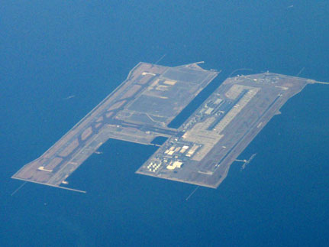

Fig 23 The top view of Kansai Airport

|  |
| --- |
| Main idea: Use a sustainable design to create a human and eco-friendly airport  Added value: Create harmony between nature and human by building artificial island including eco-community.  Specific challenge: create a design for the land subsidence in the place of second runway of the artificial island.  Developed and coordinated by: KIAC (Kansai International Airport Co., Ltd.), KALD (Kansai International Airport Land Development CO., LTD), specially designated joint venture groups  Material used (physical) : none  Material used (biological): animals and vegetation  Water system: sea water  Function: logistic and nature  Time and Space: Mega-scale and >10 years  Reference: Deltares, Public wiki, 14/12/2010 |

**Case 20: Gorai River, Bangladesh**

The Gorai River is an important artery in Bangladesh; the river is a branch of the Ganges and is the source of fresh water for the southwestern part of Bangladesh. The river is used for navigation, fisheries, agriculture and domestic purposes. Besides this, the fresh water flow of the river is also important for the ecological environment of the mangrove forests situated along the coast. During the eighties and nineties the flow of the river gradually began to slow down, especially during the dry season. The river discharge was decreasing and the annual sedimentation rate was significantly increasing. This led to a vicious circle causing difficulties for the people living along its banks and detrimental effects to the mangrove forests. To get the river flowing again, a number of solutions were considered. The design of projects includes the use of the natural flow conditions. By restoring a natural flow in the river, the river will be self-maintaining with limited maintenance dredging.

|  |
| --- |
| Main idea: Limiting maintenance dredging to restore the natural river flow  Specific challenge: Prediction of behavior of the river is difficult, so a detailed plan is impractical.  Developed and coordinated by:  Material used (physical): none  Material used (biological): none  Water system: fresh water  Function: emphasize natural value and safety, water quality  Time and Space: Marco-scale and 5 to 10 years  Reference: Deltares, Public wiki, 14/12/2010 |

**Case 21: Chongming Dongtan wetland Restoration, China**

Chongming Dongtan Wetland (Fig.24) situated in the estuary of Yangtze River near biggest city Shanghai, China. It is a rapid successive tidal flat wetland. And there are 2500 hectares of wetland created in Dongtan Island. The wetlands are mainly used for agriculture and fishery in last decades. With highly economic development of Shanghai city, the Chinese government decided to promote the use of management realignment strategies. The primary goal is to create more bird habitat, natural reed in the region as the environmental factor. The secondary goal is to use the wetland eco-system itself to purify water in Yangtze. But in this case, the environmental factors is highly influenced both locations and design. In Dongtan, the location is carefully chosen to have the maximum additional environmental value without destroying any of the existing nature. Moreover, the project also aims at shaping the flooding protection region and creating recreation benefits. The whole project is also under the behavior of Project “China eco-city”, so the residential purpose is under consideration in the future.

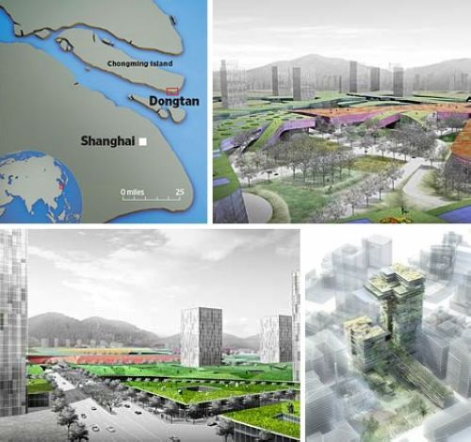

Fig 4 The location and the Planning of Chongming Island

|  |
| --- |
| Main idea: Restoring wetlands for safety, water quality and nature functions.  Added value: Creating recreation value for inhabitants.  Developed and coordinated by: Shanghai Municipality, Shanghai Municipal Oceanic Bureau  Material used (physical) : none  Material used (biological): vegetation(reed)  Water system: fresh water  Function: emphasize natural value, water quality, residence, recreation and agricuture  Time and Space: Mega-scale and >10 years  Reference: pers.comm. Mr Wang |

**Case 22: Mangroves restoration in Mekong Delta, Vietnam**

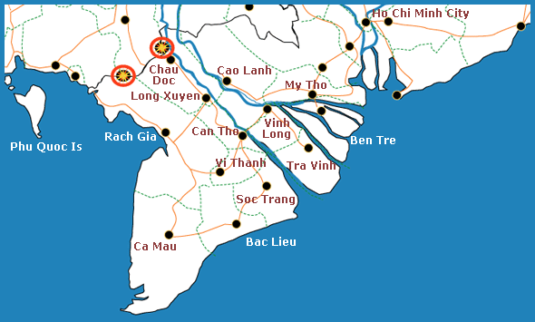Rapid expansion of shrimp farming along the south eastern Vietnamese coast has led to economic growth and poverty reduction and large areas are therefore being transformed into shrimp farms. Lacking experience on management of utilization and protection of the coastal zone has led to the unsustainable use of natural resources. This is threatening the protective function of the mangrove forest belt Shrimp farm development and degradation also caused environmental and natural resources problems. About 50% of the mangrove forest area was lost, but the reducing annual rate of the period from 1965 to 1995 was lower than that in the period from 1995 to 2000. In the period from 1965 to 2001, the total area of mangrove deforestation was 14,208 ha whereas mangrove reforestation was 5784 ha. In order to protect the coast from further erosion by the sea, recreating a strong ecosystem and to protect the hinterland from flooding, active reforestation of the local Mangrove forests along the coast seemed to be an adequate solution. Within the Coastal Wetlands Protection and Development Project (CWPDP) more than 37 million trees along 460km of coastland were planted. The project was carried out along the coastline of TraVinh, SocTrang, Bac Lieu and Ca Mau provinces of the Mekong‐Delta. The Project was founded by the World Bank and Danida with around 60.5 mil $US. It was a seven year project, which started in August 2000 and was executed by Landell Mills and Sinclair Knight Merz of Australia. The contracting body are the Vietnamese Ministry of Agriculture and Rural Development (MARD). The key objective of the project was to re-establish coastal wetland ecosystems and to sustainably protect their aquatic nurturing and coastal protection functions.

|  |
| --- |
| Main idea: Creating a strong ecosystem by restoring mangrove forests  Added value: creating extra recreation potential for local residence  Developed and coordinated by: the Vietnamese Ministry of Agriculture and Rural Development  Material used (physical) : none  Material used (biological): mangroves  Water system: fresh water  Function: emphasize safety, infrastructure, recreation, fishery and natural value  Time and Space: Mega-scale and >10 years  Reference: |

**Case 23: Restoring sand barriers, New Orleans**

New Orleans is a major United States port and the largest city and metropolitan area in the state of Louisiana. On April 20th 2010 the Deep-water Horizon oil rig caught fire and sank in the Gulf of Mexico, breaking the pipeline that connected to the underground oil field. This oil field started to leak into the gulf, resulting in a large environmental disaster. The Chandeleur islands (Fig.25) are a range of islands near New Orleans that are currently heightened up with sand to catch the oil from the Deep-water Horizon oil spill. The plan of restoring the barrier islands is making artificial sand berms to stop the oil from streaming into the Mississippi delta. They will catch oil that would end up in the wetlands behind the islands. It uses local conditions in a way that allows the natural ecosystem to form the shape of the islands (Fig.26). This approach has many benefits for oil removal and sand supply in the eroding area hinterland.

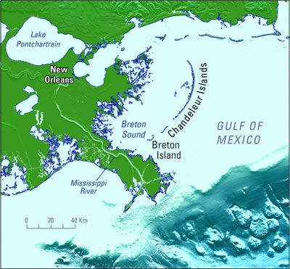

Fig 25 Top view of Mississippi Delta

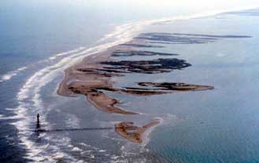

Fig 26 Sand Barriers

|  |
| --- |
| Main idea: Building sand berms to catch the oil  Material used (physical) : sand  Material used (biological): none  Water system: salt water  Function: nature and water quality  Time and Space: Mega-scale and >10 years  Reference: |

**Case 24: Restoring Oyster Reef, Louisiana**

Louisiana is a state located in the southern region of the United States of America. The nature Conservancy in Louisiana was aiming at improving the health of its marshlands and the Gulf of Mexico. One of many ways in which the conservancy works to restore the Gulf of Mexico is building Oyster reefs (Fig.27). By this way, two leading oyster reef restoration projects in Louisiana have been implemented since 2008: one at Vermilion Bay and a second in the Grand Isle/St. Bernard Marsh area. Oyster reef can not only help improving water quality, protect coast by stabilize the soil but also able to provide valuable wildlife habitat and recreational fisheries contribute substantially to Louisiana’s economy. Oyster reefs act as natural coastal buffers by absorbing wave energy, reducing erosion and trapping suspended solid. The shorelines that will be protected approximately 350 acres of existing marshes and this treatment will potentially facilitate the creation of an additional 35 acres of emergent marsh.

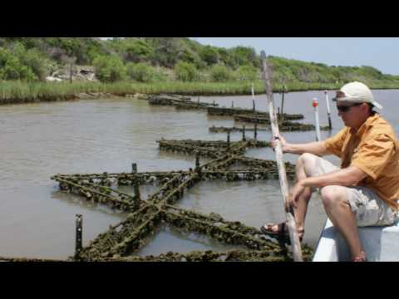

Fig 27 Example of Oyster Reef, Louisiana

|  |
| --- |
| Main idea: increasing the safety by using natural materials (oyster reef)  Added value: Combining safety, nature and economic function by using natural materials  Developed and coordinated by: National Oceanic and Atmospheric Administration (NOAA), Coastal Environments, Inc. Louisiana State University, Louisiana Department of Wildlife and Fisheries, Louisiana Department of Natural Resources, Jefferson Parish Gov, St. Bernard Parish Gov. Grand Isle Port Commission, Town of Grand Isle  Material used (physical) : none  Material used (biological): oyster reef  Water system: sea water  Function: emphasize safety, fishery, water quality and natural value  Time and Space: Meso-scale and <5 years  Reference: http://www.nature.org/?src=t1 |

**Case 25: Monaco**

Monaco (Fig.28) is one of the smallest countries in the world with a surface of only 2 km2 and a population density of more than 16,000 inhabitants per km2. It is surrounded on three sides by France, borders the Mediterranean Sea and famous for its harbors and coasted related tourism. Building with Nature concepts is applied by reserving Monaco’s original rocky seacoast. Moreover, Monaco has reclaimed new land by more than 20 percent for congress center, apartment complexes, facilities, hotels, offices, light industry and new harbors. A new beach with a length of 500m has been established at the southeastern side. 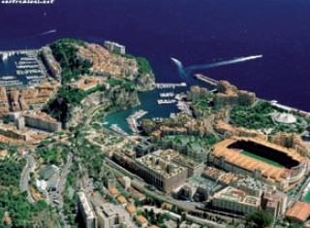

Fig 28 Top view of Monaco city

|  |
| --- |
| Main idea: Enlarging the territory by reclaiming new land and reserving original rocky coast  Added value: Creating extra economic value  Material used (physical) : sand, concrete (integrated)  Material used (biological): none  Water system: sea water  Function: add natural value based on residence, industry, recreation and logistic functions  Time and Space: Mega-scale and <5 years  Reference: Waterman, R. E. (1980-2008) Integrated coastal policy via building with nature, **P268** |

**Case 26: Cape Town-South Africa**

Cape Town (Fig.29) is both the capital of the Province of Western Cape and the parliamentary capital of the Republic of South Africa. It has eye-catching land reclamations in the Table Bay, in which land into sea and vice versa, water both into the new land and to a certain extent into the old land, are integrated. From 1860, these land reclamations follow the current coastal line over a length of 8 km with a maximum width at their center of 3 km measured from the original beach and a minimum width of a few meters at the eastern and western ends of the total land reclamation. In total, the reclamations cover hundreds of hectares with a dominating hard seawall defense and only soft sea defense at the extremities. A considerable urban development has been realized by this land reclamation, such as a central railway station, harbors, a bus station, offices blocks, a post office, a hospital, residential areas, recreation facilities and other public utilities.

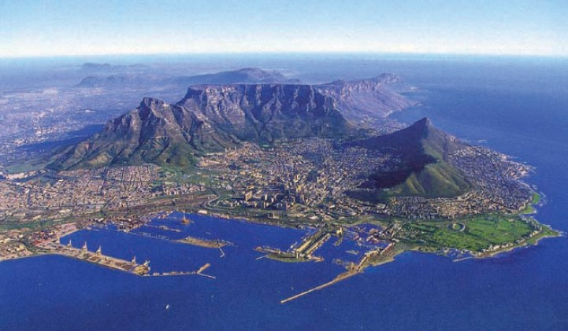

Fig 29 Top view of Cape Town

|  |
| --- |
| Main idea: Enlarging the territory by integrating reclamation and reserving old land  Added value: Creating extra potential economic value  Material used (physical) : sand, concrete (integrated)  Material used (biological): none  Water system: sea water  Function: add natural and safety value based on infrastructure, residence recreation and logistic function  Time and Space: Mega-scale and <5 years  Reference: Waterman, R. E. (1980-2008) Integrated coastal policy via building with nature, **P272** |

**Case 27: El Gouna-Egypt**

El Gouna (Fig.30) is located at the Red Sea in Egypt, bordering the Eastern Egyptian Desert. Similar to Cape Town, this region has been executed in which land into sea and sea into land are completely integrated. The area consists of a series of larger and smaller islands and peninsulas, linked to each other and to the mainland with specially designed bridges. In this way, lagoons and marinas were created with beaches, quays and terraces. Beaches are present both with and without foreshore protection. Panorama both above and under water can be observed at a short distance from this created island coast. Thus, ecotourism with the help of professional guides and environmental guidelines is strongly emphasized in order to prevent damage to the existing nature. Besides that, many opportunities exist for purely beach-oriented recreation.

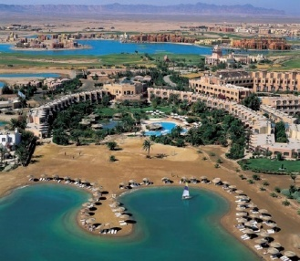

Fig Recreation site in El Gouna

|  |
| --- |
| Main idea: integrating land into sea and sea into land for recreation  Material used (physical) : sand, concrete (integrated)  Material used (biological): none  Water system: sea water  Function: add natural value based on recreation function  Time and Space: Mega-scale and <5 years  Reference: Waterman, R. E. (1980-2008) Integrated coastal policy via building with nature, **P277** |

**Case 28: Tel Aviv/Jaffa& Haifa, Israel**

Tel Aviv was founded in 1909 in the dune area and it is now the most important commercial business center of Israel. Three coastal extensions projects are implemented along the Tel Aviv/ Jaffa (Fig.31&32) seafront since 2002. The plan combines a system of several solid sea-wall elements, consisting of a harbor mole and an additional three breakwaters alternated by three pocket beaches and an inner harbor beach with a total shore length of 1km. It also comprises the development of a total 56 ha south and west for the existing fishing port. The wet area in the new port area consists of 13 ha and the dry area is 43 ha including a shore park of 10 ha. The whole project includes a number of other functions: residential, recreation and infrastructure. Another similar case in Israel is Haifa with a population of 284,000 inhabitants (2002). As the third city by size in Israel, it has significant port and an industrial zone reaching the still contaminated Kishon River. The scarcity of space and the necessity of enlarging the port resulted in a series if land reclamations within the Haifa Bay.

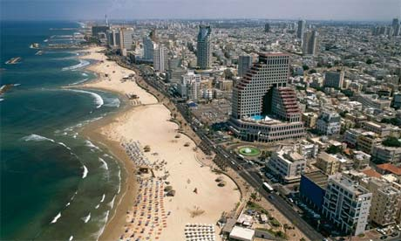

Fig 31 Jaffa coast

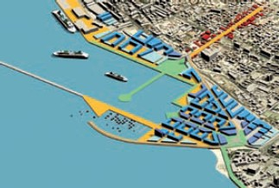

Fig 32 Planning of Haifa coast

|  |
| --- |
| Main idea: Enlarging the territory by integrating reclamation  Added value: Creating extra potential economic value  Material used (physical) : sand, concrete (integrated)  Material used (biological): none  Water system: sea water  Function: add natural and safety value based on residential, infrastructure, industry, recreation, logistic, fishery function  Time and Space: Mega-scale and >10 years  Reference: Waterman, R. E. (1980-2008) Integrated coastal policy via building with nature, **P284** |

**Case 29: Red Sea/Dead Sea connection, Israel/Jordan**

The Dead Sea is a large inland saltwater body with a surface area of 950km2, bordering Jordan, Israel and Palestinian. The main water source of Dead Sea is Jordan River. Since the Jordan River has been used increasingly for irrigation and water supply, the water inflow for the Dead Sea has become disrupted. That causes the decline of water level in Dead Sea. The idea of Linking the Dead Sea to either the Mediterranean Sea or the Red Sea was born already in 19th century. Now the plan has been implemented by combining restoring and keeping the water level of the Dead Sea with the production of hydro-electricity and using hydrostatic pressure difference for the production of desalinated seawater through membrane filtration. In this way, an important solution for the existing and predicted water deficit for the region of Israel, Jordan and Palestinian can be achieved. Instead of integrating land into sea, this is the unique project integrating the intake of seawater into the existing land-water system.

|  |
| --- |
| Main Idea: Using hydropower for an integrated water system  Material used (physical) : sand, concrete (integrated)  Material used (biological): none  Water system: salt water  Function: nature, water supply and infrastructure function  Time and Space: Mega-scale and >10 years  Reference: Waterman, R. E. (1980-2008) Integrated coastal policy via building with nature, **P288** |

**Case 30: Gaza Strip, Palestine**

The Gaza Strip has a coastal length of 42km and an inland width varying from 6-12km under Palestinian Authority. It has an 11km border with Egypt and a 51km border with Israel with a total land surface of 360km2 and a population approaching 1,5million. For the reason of scarcity of space and land, Gaza Strip (Fig.33) also has to extend the landscape by concept Building with Nature. The bandwidth of the land reclamation along Gaza Strip is limited to a maximum of 1,000 m. The new land largely consists of dunes and beaches and takes fully into account existing land uses of coastal area. The new land could be developed for related facilities. For example, boat and yacht maintenance, fish market, warehouses, container port, logistics and distribution centers, wastewater purification plants, a tax free zone for wholesale and retail trade, hotels, offices and apartments.

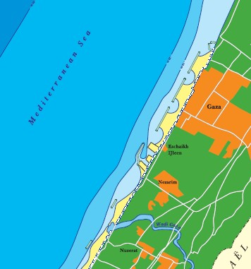

Fig 33 Reclaimed land in Gaza Strip

|  |
| --- |
| Main Idea: Enlarging the territory by integrating reclamation  Material used (physical) : sand, concrete (integrated)  Material used (biological): none  Water system: salt water  Function: nature, logistic, infrastructure and residential  Time and Space: Mega-scale and 5 to 10 years  Reference: Waterman, R. E. (1980-2008) Integrated coastal policy via building with nature, **P293** |

**Case 31: Artificial Island Dubai, United Arab Emirates**

The famous artificial island Palm Island Jumeirah can be considered as one of the most spectacular examples of land reclamation in the world. It was inspired by nature through the vision of a date palm tree projected in the sea and linked to the coast. The Palm Island is connected by a causeway and bridge to the original coast. There are also high quality hotels, utilities for energy and freshwater supply, ICT provisions, sewer system and wastewater purification units. Besides the Palm Island, there are other several projects concerning land reclamation and concepts Building with Nature. They are The World, The Palm Deira, Palm Island Jebel Ali, Dubai Waterfront, Dubai tower and so on, see Figure 34. It total reclaimed land area exceeding 15,000 ha and the creation of some 1400km of water frontage. The mega developments using 2,1 billion m3 sand will add massively to the original 72km natural Dubai coastline. With the modern development, Dubai has become an important logistic, distribution and trade center between Europe and Asia.

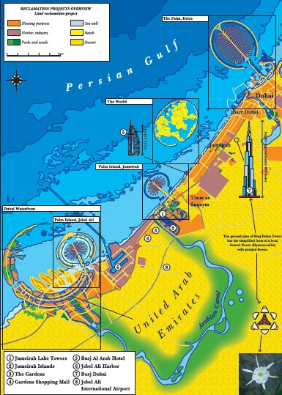

Fig Locations of Dubai project

|  |
| --- |
| Main Idea: Enlarging the territory for development by integrating reclamation  Material used (physical) : sand, concrete (integrated)  Material used (biological): none  Water system: salt water  Function: Nature, safety, infrastructure, water supply and recreation  Time and Space: Mega-scale and >10 years  Reference: Waterman, R. E. (1980-2008) Integrated coastal policy via building with nature, **P306** |

**Case 32: Curacao, the Caribbean**

Curacao belongs to Lesser Antilles and situates in the Caribbean. It located off the coast of Venezuela at a distance of around 70km with a surface area of 444 km2 and a population of 150,000. As known under the name of Curacao Sea Aquarium (Fig.35), the project concerns a transformation of a coastal segment on the southwestern side of Curacao, east of Willemstad with a length of 1km. The project comprises parks, artificial beaches, specially designed coast parallel breakwaters, lagoons, ocean resort and infrastructures. The whole project lasts for several years since 1990, around 80,000m3 limestone boulders were quarried in the hinterland of Curacao. After that, the coast parallel breakwaters and their niches acted as an attractive substratum for marine organisms, see Figure 36.

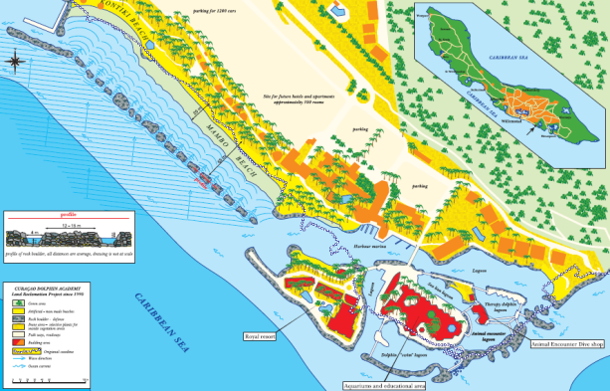

Fig Planning of Curacao coast

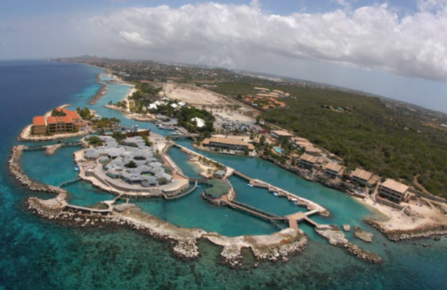

Fig View of breakwaters and their niches along Curacao coast

|  |
| --- |
| Main idea: Using existing conditions to create new coastal segment  Material used (physical) : sand, limestone, concrete (integrated)  Material used (biological): none  Water system: salt water  Function: Nature, safety, infrastructure and recreation  Time and Space: Micro-scale and <5 years  Reference: Waterman, R. E. (1980-2008) Integrated coastal policy via building with nature, **P375** |

**Case 33: Restoration of Rio Biobio River, Chile**

The Biobío River (Fig.37) is the second largest river in Chile. It originates from Icalma and Galletué lakes in the Andes and flows 380 km to the Gulf of Arauco on the Pacific Ocean. Over 1 million people use the resources of the Rio Biobio for drinking and irrigation water, recreation and fishery. Another six hydro-electric dams in the upper part is being constructed. The lower part was navigable for 100km. But since the extensive logging of trees for timber, erosion of the river occurred. This caused a wider and shallow river bed which reduced navigability and had a bad impact on the ecosystem. A restoration project is carried out by the concept of Building with Nature. By planting trees and shrubs on the slopes, erosion has been stopped and the riverbank has been restored. And sedimentation forces the river into a narrow and deeper riverbed. Therefore, restoring the riverbed increases the navigability.

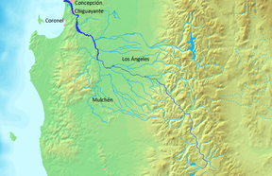

Fig 37 Location of River Rio Biobio

|  |
| --- |
| Main idea: Restoring riverbeds by planting trees on the slopes  Material used (physical) : none  Material used (biological): trees  Water system: fresh water  Function: Nature, agriculture, recreation, fishery and navigation  Time and Space: Macro-scale and 5 to 10 years  Reference: Waterman, R. E. (1980-2008) Integrated coastal policy via building with nature, **P397** |

**Case 34: Negros Oriental, the Philippines**

The need for coastal management in the Philippines became relevant after the flooding from the typhoons in 1969 and 1971. Three integrated coastal zone management projects consisted of 140 small projects have been implemented in the Negros Oriental (Fig. 38), Philippines. They are Central Visayas Regional Project (CVRP) (1984-1992), Environmental and Resources Management Project (ERMP) (1990-1992) and Coastal Resources Management Project (CRMP) (1996-2004). The CVRP project aims to work against poverty of inhabitants and environmental destruction. It is led by Central Visayas Regional Project office and funded with 25, 6 M dollars by the World Bank. In an integral way Marine Sanctuaries have been declared, mangroves have been reforested on the coastal line and artificial reefs have been placed. The ERMP project aims at restoring local forest and water system which includes drinking water system close to the coast and marine water system on the shore. It is conducted by Silliman University and funded by Canadian International Development Agency. And the CRMP project focused on mangroves rehabilitation, technical assistance and integrated management of every participant. It is implemented by Philippines department of environment and natural resources and funded by US Agency for international development.

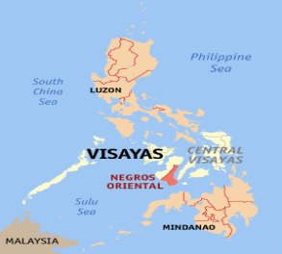

Fig Location of Negros Oriental in the Philippines

|  |
| --- |
| Main idea: integrating coastal areas by restoring mangrove forests, building artificial reefs  Added value: creating extra recreation and economic potential for local residence  Developed and coordinated by: Central Visayas Regional Project office, Silliman University and Philippines department of environment and natural resources  Material used (physical) : none  Material used (biological): mangroves, reefs  Water system: sea water  Function: nature, safety, fishery, aquaculture, recreation and industry function  Time and Space: Macro-scale and 5 to 10 years  Reference: |

# 4. Conceptual Framework

The conceptual framework is based on the analysis of different cases all over the world. It aims at summarizing characteristic aspects of *Building with Nature* from practical usage of cases. Four tables will indicate different factors:

The first table describes the design with the components, which includes both physical and biological aspects.

The second table is focused on analyzing the ecosystem engineering scale and time used in practices.

The third table aims at stakeholder analysis and is more specifically focused on applied functions.

The last one is about water system analysis which refers to the salinity of water body.

## 4. 1. Components of design

The interactions and forces which are exposed to nature are the most related characteristic aspect concerning the concepts *Building with Nature*. The materials can interact with each other and are used as the components of design include two aspects: one is physical parts such as sediments (soft structure), mixed sand and concretes, concretes (hard structure), the other one consists of biological parts like the abiotic environment (sand), animals (e.g. mussels or oysters) and vegetations (e.g. marshes or reeds). Meanwhile these used materials are interacting; the optimal nature is present in the design. In this way, they integrated with each other and gave influences on ecosystems. The components in this table are the climax design.

|  |  |  |  |  |
| --- | --- | --- | --- | --- |
| Components of the design | Soft structure  sediment | Mixed sediment and hard structures | Hard structures | Other actions (dredging, restoration, depoldering, etc.) |
| Abiotic | 1.Classic Dutch coastal nourishment  8.Sand Engine  14.Galgeplaat nourishment  16.Mini Sand Engine Frise IJsselmeerkust  23.Restoring sand barrier ,New Orleans | 5a.The Maasvlakte 2 |  |  |
| Flora functional | 2.Salt Marsh, Groningen and Friesland  6.Afsluitdijk, Nature Driven Design  11.floating Marshes | 7.Wave reducing eco dyke  15. Overdijk Markermeer | 3.Eco-Concrete | 9.Room for River  20.Gorai River  21.Chongming wetland  22.Mangrove restoration  33.Rio Biobio River, Chile |
| Mixed flora and fauna functional |  | 18.Le Havre Port + Bird Island  19.Kansai international Airport  25. Monaco  26.Cape Town, South Africa  27.El Gouna, Egypt  28.Tel Aviv/Jaffa&Haifa, Israel  30.Gaza Strip, Palestine  31.Dubai  32.Curacao, the Caribbean | 3.Rich Revetment | 5b.Ecological mining pit  13.Perkpolder  17.Wetland Restoration Wallasea island, UK  29.Red Sea/Dead Sea connection  34.Negros Oriental, the Philippines |
| Fauna functional | 10.Shellfish Reef |  | 12.Harboring Opportunities | 24.RestoringOysterReef,Louisiana |
| Table 1 Components of the design | | | | |

**Discussion:**

As one can clearly see from table 1, most of the international cases fit in the category of mixed flora and fauna combined with mixed sediments and hard structure. That appears logical since it is just appropriate for the concept *Building with Nature*. Making full use of nature components existing in the occurring system is paramount for the ecosystem. Surprisingly, there is no Dutch case present here. On the other hand, three Dutch cases are found where only flora function is present and other four Dutch cases are fit in the abiotic environment, only formation of sediments is represented in the main design. That means the classic Dutch coastal defense method is focused on sand nourishment. However, two other Dutch pilot cases show a trend of using more flora function based on mixed sediment and hard structures. In the case of Wave reducing eco dikes, willow plantations as flora function to minimize the wave actions in front of low dikes are used. The Case Eco-concrete is enabling plantations working on hard structures. Another trend shows opportunities for fauna functional, the case Harboring Opportunities use filter feeders as fauna function to improve the water quality and also influence the wave actions near harbors. But there is no case present in the cell which combined fauna functions and mixed soft and hard structure. Moreover, some other actions or measures have also been implemented in the cases. Restoring the original nature ecosystem is commonly used on a global scale. For example, plantations, mangroves, oyster reefs and sand barriers can be found everywhere in the world. Other actions like lowering floodplains, relocation of dikes, depoldering and deepening summer beds (Room for River), limiting maintenance dredging to restore the river flow (Gorai River) are applied in specific situations. Last but not least, because of the local geographic conditions and needs for water supply, the case Red Sea/Dead Sea connection is the only project that uses hydropower to integrate the intake of seawater into the existing land-water system.

## 4. 2. Ecosystem engineering species and time used

A country like The Netherlands, as in all the densely populated coastal areas around the world, has only little space available for living, working, transport and recreation, while at the same time there is the need to preserve or even enlarge natural coastal and deltaic habitats. This is where the principle of *Building with Nature* fits in very well. By using sufficient land, human should create extra value in a sustainable way. This becomes a important conditions for social development nowadays. Within the limited space, the Dutch built the delta works in fast pace. Finding a cost-effective solution for all delta areas becomes a crucial challenge. The table below presents ecosystem engineering species in coastal protection. By integrating the species, different spatial scales need to be distinguished. The division below is based on the analysis of professional research which indicates the different ecosystem engineering species. Micro-scale solutions aim to optimize texture and structure of concrete in the intertidal zone. Meso-scale solutions refer to mussel beds and oyster beds for protecting intertidal flats from erosion. Macro-scale options are related to building willow floodplains to reduce wave overtopping of dikes. In addition, Mega-scale options are using sand dunes and wetlands for coastline protection [9]. The framework is proposed to include ecosystem engineering species in coastal protection, by focusing on the integration of spatial and temporal scales between ecology and engineering. Because of case selections, the time scale is generally divided into 3 rows, which are <5 years, 5 to 10 years and >10 years. They indicate the time that is used in every project from planning stage until making full use of all components in the design.

|  |  |  |  |
| --- | --- | --- | --- |
| Dimension and Time | Time of project  <5 years | Time of project  5 to 10 years | Time of project  >10 years |
| Micro-scale  (Texture) | 3.Eco-Concrete  4.Rich Revetment  32.Curacao, the Caribbean |  |  |
| Meso-scale  (Mussel beds, oyster reef) | 10.Shellfish Reef  12.Harboring Opportunities  24.RestoringOysterReef,Louisiana |  |  |
| Macro-scale  (willow plaints) | 5b.Ecological mining pit  7.Wave reducing eco dike  11.floating Marshes  15.Oeverdike Markermeer  16.Mini Sand Engine | 9.Room for River  13.Perkpolder  20.Gorai River  33.Rio Biobio River, Chile  34.Negros Oriental, the Philippines |  |
| Mega-scale  (dunes and wetland) | 5a.The Maasvlakte 2  14.Galgeplaat nourishment  23.Restoring sand barrier, NewOrleans  25. Monaco  26.Cape Town, South Africa  27.El Gouna, Egypt | 1.Classic Dutch coastal nourishment  6.Afsluisdijk, Nature Driven Design  30.Gaza Strip, Palestine | 2.Salt Marsh, Groningen and Friesland  8.Sand Engine  17.Wetland Restoration Wallasea island, UK  18.Le Havre Port + Bird Island  19.Kansai international Airport  21.Chongming wetland  22.Mangrove restoration  28.Tel Aviv/Jaffa&Haifa, Isreal  29.Red Sea/Dead Sea connection  31.Dubai |

Table 2 Scale and time

**Discussion:**

Generally one can see from the tables that it is logical that larger cases take more time in the implementation phase while smaller cases take less time. But in reality, the pace of implementing a project also depends on the current needs of the population. The case Maasvlakte 2 is an example of using a lot of space but a short timeframe (<5 years). Because of economic demand and industrial purpose, both design and implementation phase are working at very fast pace. Comparing with that, causing by restoring nature purpose, the case Chongming wetland is using almost the same amount of space but a longer time span (>10 years). Furthermore, scale and time always depend on the needs from reality which are related to local society. The demand for finishing the project is the key factor for time scale

## 4. 3. Function analysis

The biggest challenge of the 21st century is the development and implementation of methods that at the same time strengthen the economy and also improve the environment, while making optimum use of the available space. In addition to that, sustainability of production and consumption processes should be strived for in delta areas. The local safety infrastructure, education, residential, agriculture, industry, recreation (business purpose), logistic, fishery), navigation (Public transport purpose), water quality and nature should be considered under the development framework. For analyzing purposes, sustainability is divided into three parts which represent people, planet, and profit. The table below separates all functions to people, planet and profit.

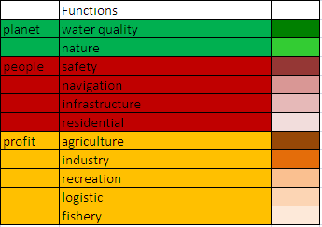

Table 3 sustainability division of functions

The table below summaries 32 cases in total with their functions.

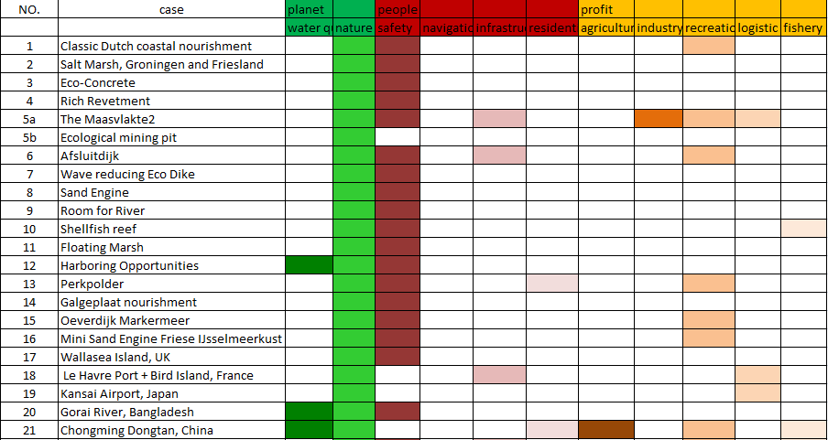

Table 4 Summary table for functions cont.

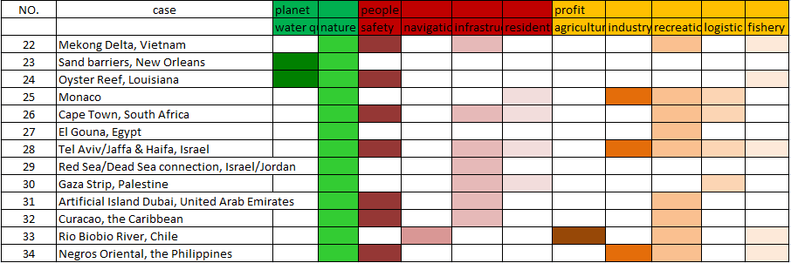

Table 5 summary table for functions

**Discussion:**

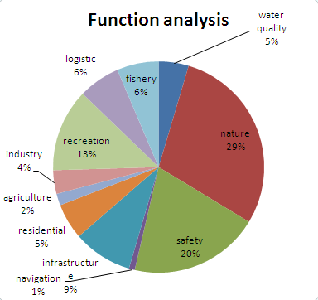

Fig 39 Function analysis chart 1

From the figure, it is obvious that nature and safety functions play big roles which are 29% and 20% in all cases above. Recreation (13%) and infrastructure (9%) are following up. Water quality (5%), fishery (6%), logistic (6%), residential (5%) and industry (4%) come after those two. Agriculture and navigation only count for 2% and 1%.

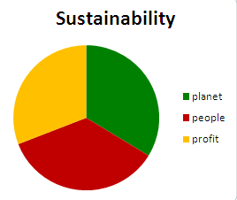

Fig 40 function analysis chart 2

The figure above shows the sustainable factors, planet, people and profit, which are almost equally distributed. Only the people (36%) branch is slightly higher than planet (34%) branch. And the profit branch makes up 31%. From this result, three branches from sustainability are balanced with each other. This matches the concept of *Building with Nature* and highlights the harmonious development of all elements.

## 4. 4. Water system

The water system integrates physical, chemical, and biological processes that sustain ecosystems and related climate change. The water system also influences the regional fresh water supply and soil quality. It includes the water system (fresh, brackish or salt), the tidal system and water quality (chemical, biological). So a better understanding of the whole system provides a better foundation for decisions and investments by policymakers, managers, and stakeholders. Table 7 below is focused on water system analysis which divides all cases into fresh, brackish and salt water bodies.

|  |  |
| --- | --- |
| water system | case |
| fresh water system | 7. Wave reducing Eco Dike  9. Room for River  15.Oeverdike Markermeer  16.Mini Sand Engine  20. Gorai River, Bangladesh  21. Chongming Dongtan wetland Restoration, China  22. Mangroves restoration in Mekong Delta, Vietnam  33. Rio Biobio River, Chile |
| brackish water system | 3. Eco-Concrete  4. Rich Revetment  6. Afsluitdijk  11. Floating Marsh  13. Perkpolder  14. Galgeplaat nourishment |
| salt water system | 1.Classic Dutch coastal nourishment  2. Salt Marsh, Groningen and Friesland  5a. Maasvlakte2  5b. Ecological mining pit  8. Sand Engine  10. Shellfish reef  12. Harboring Opportunities  17. Wetland Restoration in Wallasea Island, UK  18. Le Havre Port + Bird Island  19. Kansai International Airport  23. Restoring sand barriers, New Orleans  24. Restoring Oyster Reef, Louisiana  25. Monaco  26. Cape Town-South Africa  27. El Gouna-Egypt  28. Tel Aviv/Jaffa& Haifa, Israel  29. Red Sea/Dead Sea connection, Israel/Jordan  30. Gaza Strip, Palestine  31. Artificial Island Dubai, United Arab Emirates  32. Curacao, the Caribbean  34.Negros Oriental, the Philippines |

Table 6 Water system

**Discussion:**

While the sea level rising problems mostly have effects on coastal areas, and the concept of *Building with Nature* contains a lot of interaction between sand/silt/clay particles, marine organisms, sea currents and tides, it is easy to find that many cases have salt water systems. But there are a few cases that belong to fresh water systems and brackish water systems. Thus there are a lot of opportunities for researchers and experts to pay more attention to fresh and brackish water systems.

# 5. Chinese experience with integrating management approach

The ancient Chinese method Tianshi Dili Renhe is commonly used in Chinese way of thinking for planning a project*.* And gathering three elements are the goal.

In the Chinese term, people who want to seek success must meet the three conditions of time, place and guanxi (relationships). In traditional Chinese culture this is called Tianshi Dili Renhe. Seizing upon the climate and Zeitgeist of the era (Tianshi or will of Heaven), commanding proper location (Dili or resources of Earth) and developing guanxi (Renhe or relationships of Mankind) is the fundamental principle—the Tao. Tianshi (T) is inherently fair, since anyone in a given time will be equally affected. Dili (D), however, is perpetually concerned with scarcity and unavailability. As such, Renhe (R) has the greatest potential for modification and maneuverability.

In this research, case Maasvlakte 2 has been selected as an example for applying the method Tianshi Dili Renhe. In this case, the economic development, sea level rising and coastal defense are the chances for the project. So this refers to Tianshi. Dili always regards to conditions. Old harbors, supply of sand and other materials, local water systems, time spent and size of the project are the conditions for the implementation of a project. Renhe is concerning the cooperation between management and functionalities, the governments responsible for Maasvlakte 2 is Rotterdam Authority, Rotterdam City Hall, managed and developed by port of Rotterdam Authority, consulted by Royal Haskoning. And the other partners who get involved are Deltares; TU Delft. And functions of the whole project are nature, infrastructure, industry, recreation, logistic and safety. The better cooperation that different stakeholders can achieve, the better the maneuverability of the project.

For the concepts *Building with Nature*, Tianshi refers to opportunities and time which is more related to ambient conditions such as the sea level rising, the global warming, the population pressure, the climate change or the economic booming. It depends how strong the desire is and the ability of people to tackle problems. Dili refers to local geographic and basic conditions. For example, the material and space that can be used in the local systems concerning biological, chemical and physical aspects. It is also important to measure how the components in the design have been implemented. Normally, using less time with the highest efficiency is the goal of creating a Dili condition. Renhe refers to cooperation between management and functionalities, the better cooperation that people can achieve, the better maneuverability of the project can get. When (T) and/or (D) fall short or are in short supply, (R) will always have the final say. This is the basis for why Chinese society regards (R) as paramount. Mencius said, “Tianshi is inferior to Dili, Dili is inferior to Renhe.” 2,500 years of Chinese history has proven his words ring true in every age.

# 6. Conclusion and recommendations

###### In this research the analysis of concept *Building with Nature* has been done. Analyzing the concepts Building with Nature in delta areas is intended to structurally analyze the data and information that was gathered from the cases. During the collection of cases, one of the most striking observations is some of cases is obviously typical Dutch cases, and vice versa. Typical Dutch cases are always associated with coastal sand nourishment or using sediments as material in the ideal design. The only Dutch cases which are not concerning sediments were focused on using biological materials in tidal areas whether flora or fauna to minimize the wave actions, to stabilize and catch sediment in order to strengthen coastal system. On the other hand, non-Dutch cases have different methods or purposes for integrating coastal systems. Thus an integrating approach of coastal management is recommended, multifunctional use of natural conditions and to have an ecological friendly design is crucial for BWN concepts.

# 7. Reference

[1]. http://www.ronaldwaterman.com/page10/page12/page12.html

[2].http://en.wikipedia.org/wiki/Integrated_coastal_zone_management

[3].http://en.wikipedia.org/wiki/Coastal_management#Hard_Engineering_methods

[4]. http://www.ecological-engineering.com/defs.html

[5].Mitsch, W.J. and Jørgensen, S.E. (2003) Ecological engineering: a field whose time has come, *Ecological Engineering*, **20:**363-377

[6].Waterman, R. E. (1980-2008) Integrated coastal policy via building with nature, Opmeer drukkerij bv, The Hague, **pp.** 450

[7].http://www.ecoshape.nl/ecoshape-english/home/welcome-on-the-website-of-building-with-nature?set_language=en

[8].http://en.wikipedia.org/wiki/Current_sea_level_rise

[9]. **Bas W. Borsje****, 2010 Bregje K. van WesenbeeckFrank Dekker, Peter Paalvast, Tjeerd J. Bouma, , Marieke M. van Katwijk and Mindert B. de Vries. _**How ecological engineering can serve in coastal protection **pp.** 3-6